Nama: Vinson Luckianto

NIM: 2602091066

Kelas: BF-01

Jurusan: ComputerScience/S1

Kampus: Kemanggisan

## Soal

*Case*

**SpaceTD**

**SpaceTD** is a private Indonesian aerospace manufacturer and space transportation services company founded in 2002. The company's mission is to reduce space transportation costs and enable the colonization of Mars. SpaceTD designs, manufactures, and launches advanced rockets and spacecraft, with the goal of creating reusable launch vehicles that can be used for multiple missions. Some of SpaceTD's notable achievements include the first privately funded liquid-propellant rocket to reach orbit (Falcon 1 in 2008), the first privately-funded company to successfully launch, orbit, and recover a spacecraft (Dragon in 2010), and the first privately-funded company to send a spacecraft to the International Space Station (Dragon in 2012).

SpaceTD is currently planning to create a website for their service, so they can reach more people from all around the world. First, SpaceTD needs to create a **website prototype** and company website that represents the SpaceTD image. With this website, SpaceTD hopes to improve service to its customers. SpaceTD entrusts you as a web designer to design their website prototype and create a company website.

The **requirements** from SpaceTD are described below:

1. SpaceTD wants you to design the **website prototype** of all **five pages** before making the HTML files. The website prototype will be created using **Figma**. Ensure the website prototype that you created is the **exact same** as the website that you will make later. Each page will contain **header**, **navigation**, **content**, and **footer** as its structure. Consider the **color**, **layout**, and **consistency** when designing the prototype.
2. SpaceTD wants you to build the **website attractive**, **appealing**, **fully functional**, and make sure the website is **responsive**. The website should be accessible using a mobile phone in a perfect way. To achieve that, use **5 kinds of CSS property** and **JavaScript**. Use **meta viewport tag** and **media screen rule** that will be applied if the screen is **below 768px screen width**.
3. The website consists of **five main pages**. They are **Home Page**, **Vehicles Page**, **Register Page**, **Programs Page**, and **Launches Page**. Below are the requirements for each page:
   * **Home Page**

This page shows SpaceTD’s **rocket launch video**, SpaceTD in numbers including **number of successful launches**, **landings**, **and reflights**. This page also shows SpaceTD’s **vision**.

* + **Vehicles Page**

This page shows all **list of SpaceTD’s space transportation**. Make sure to provide the **name, overview** (such as height, diameter, weight, etc.), and **image** **of the transportation** so people can get better insight about the transportation.

* + **Register Page**

This page provides a register form for the people who want to travel to space. SpaceTD needs a person’s **personal information**, such as **full name**, **gender**, **email**, **date of birth**, **password**, and **country**. You are asked to create **five kinds of form components** and **five kinds of validation**. For validation, you must create it using **JavaScript** and **don’t use regular expression**.

* + **Programs Page**

This page shows **all SpaceTD’s space travel programs**. Make sure to provide **name**, **description**, **flight** **duration**, and **image**.

* + **Launches Page**

This page shows **recent SpaceTD’s space mission**. Make sure to provide **launch date**, **mission** **name**, and **rocket launch image**.

**Guidelines:**

* + - * 1. Design your website by observing the principles of **human and computer interaction**. Set up your site as **creative** as possible but still strive for **consistency**.
        2. The **website prototype** must be designed using **Figma** and make suretocreate some **features**, such as color and text style, effect, component, variant or interactive component, and navigation.
        3. Consider the **color**, **font**, **size**, and **layout** that you use to design the prototype and website.
        4. All pages mentioned in the requirement should be created **based on your template design**.
        5. Use only **external** **CSS**. Internal or inline CSS will not be marked.
        6. Use **CSS box positioning** to design your web structure**,** do not use table for the layout.
        7. Consider the **language** you use, including spelling and grammar, feel free to choose either Bahasa or English, but you cannot have both at the same time.
        8. Make your website **responsive** so it can deliver in any size, particularly for **desktops**, **tablets,** and **mobile devices**.
        9. Organize your files with subdirectories.
        10. Include references (link from a website, book, etc) that you use in creating the website.

**FIGMA**

* **HOME PAGE**

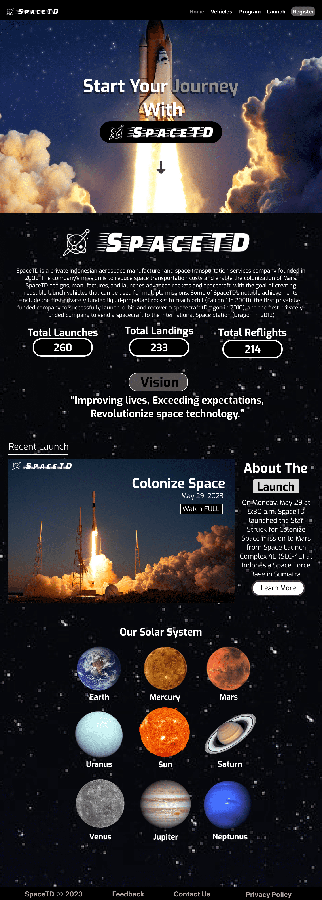

* **VEHICLES PAGE**

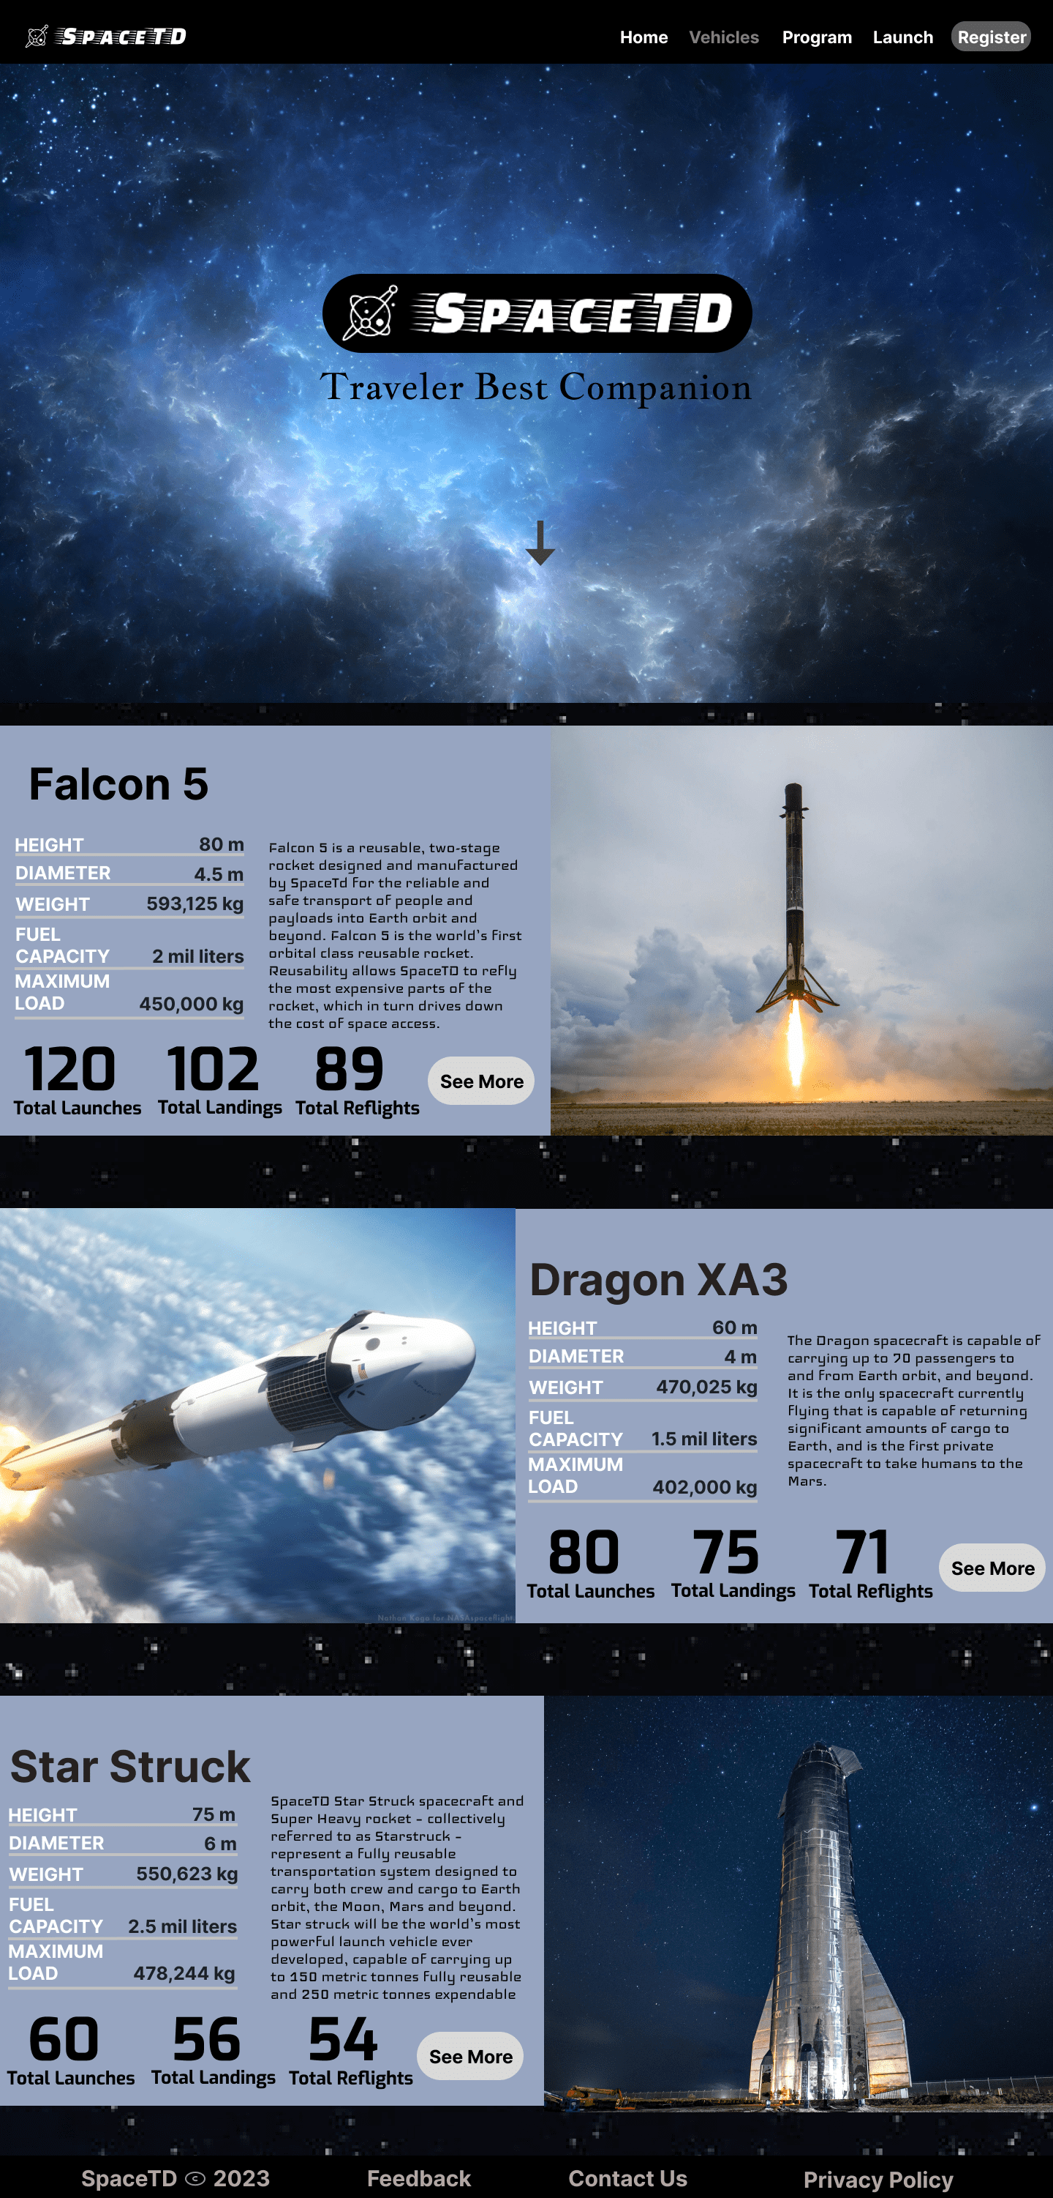

* **PROGRAM PAGE**

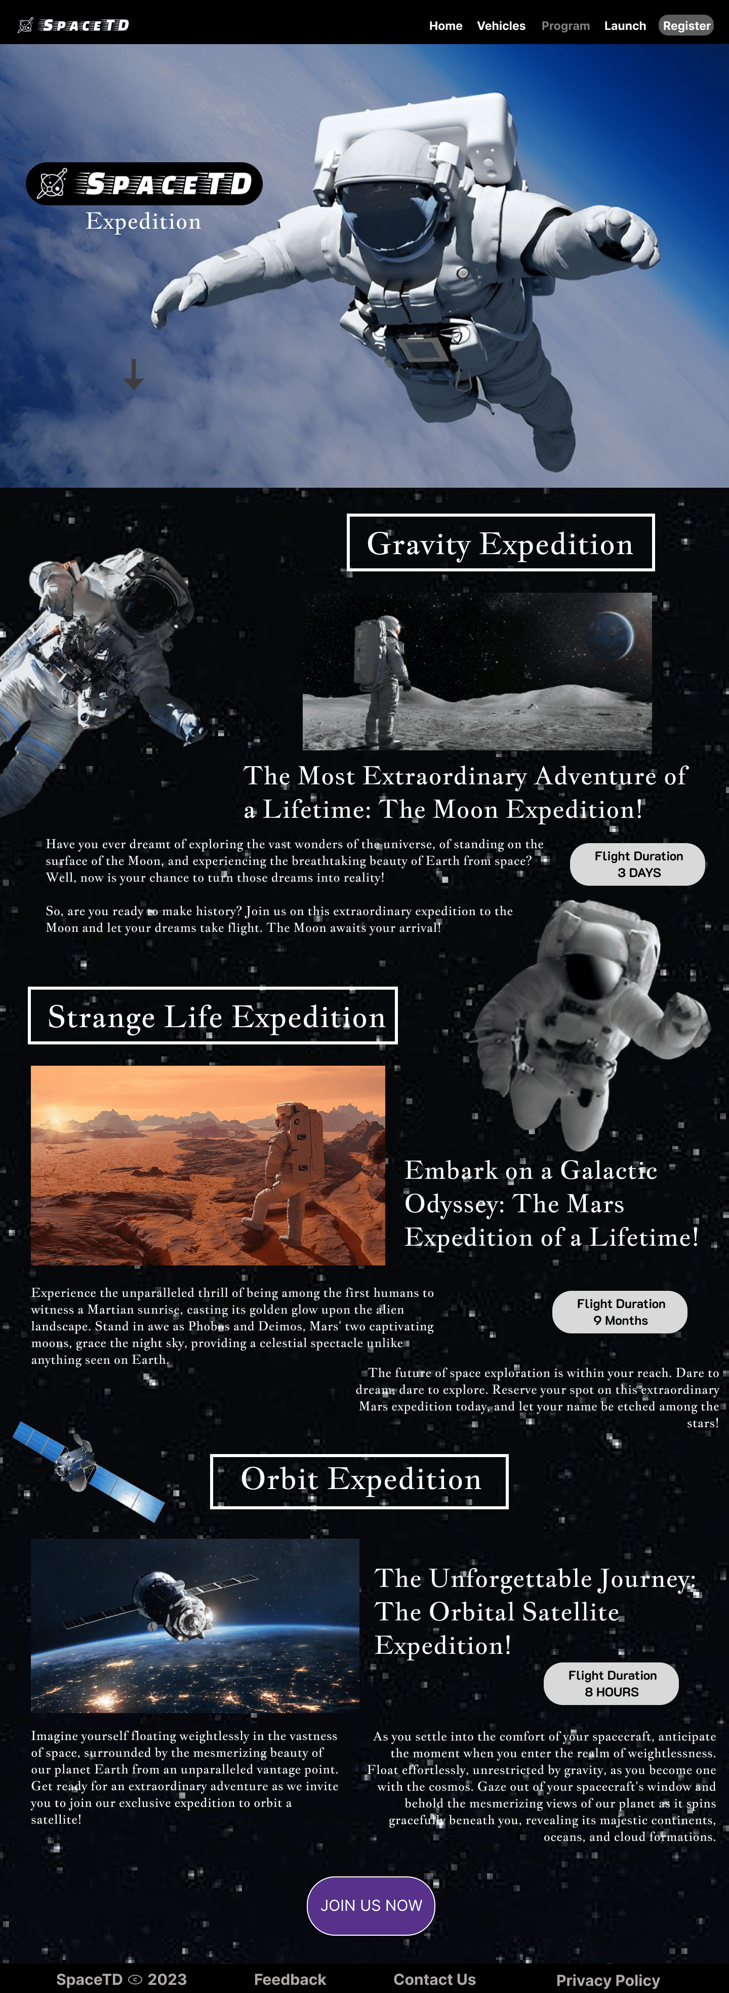

* **LAUNCH PAGE**

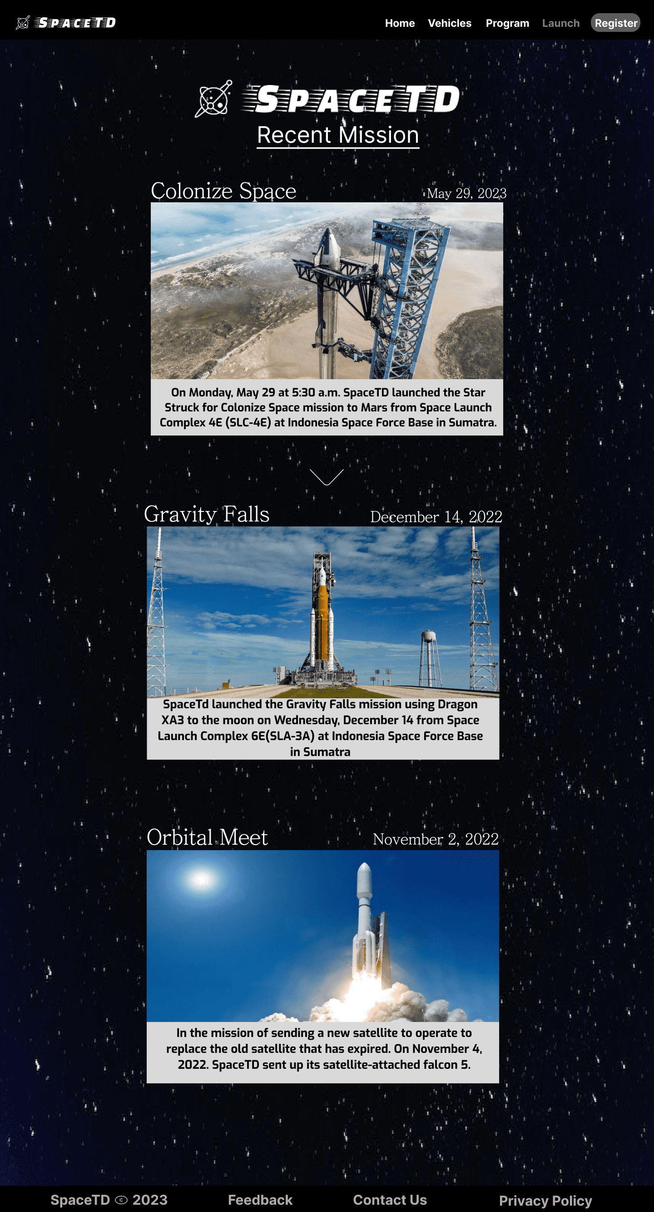

* **REGISTER PAGE**

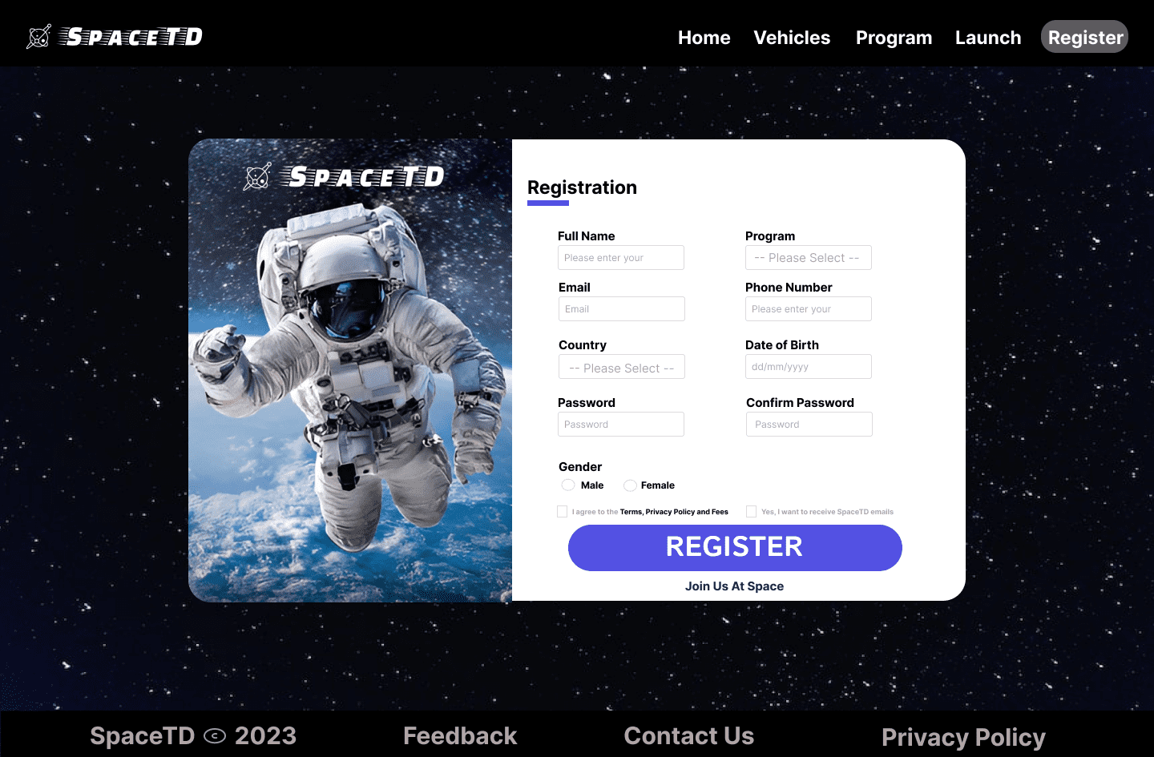

REGISTER(EMAIL SEND NOTIFICATION)

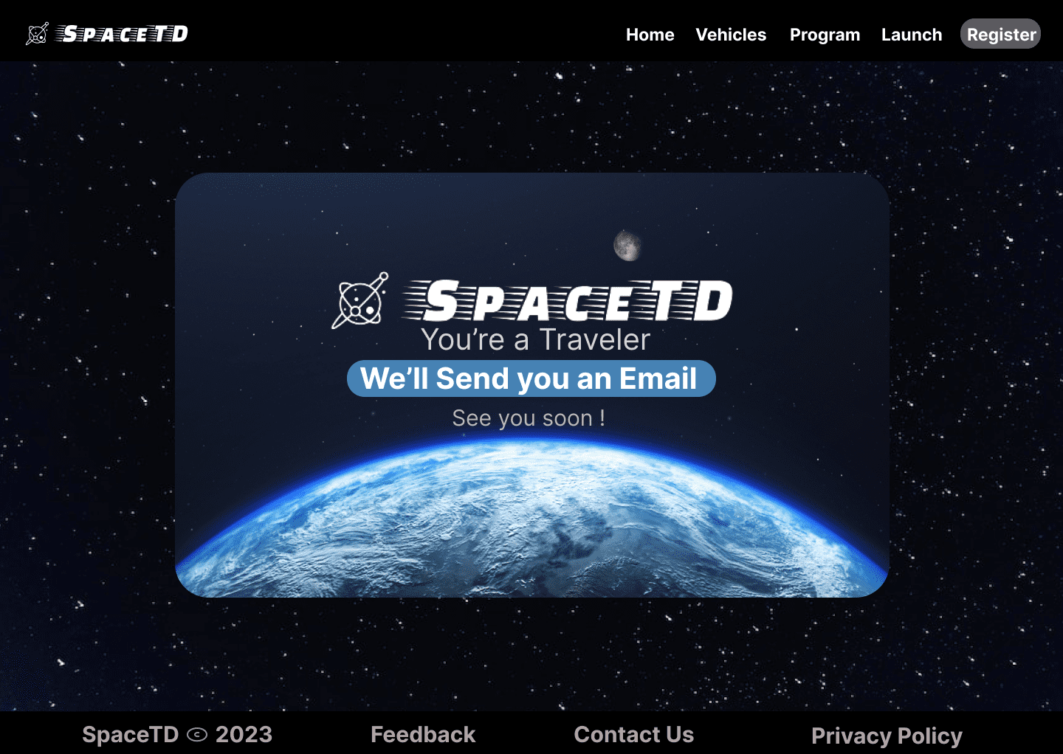

LINK:

* SpaceTD Website Figma:

<https://www.figma.com/file/qIjZhhtseZrwqhgmIDQzXD/SpaceTD?type=design&node-id=0%3A1&t=yPdnofZweuhVKoDp-1>

* SpaceTD Website Prototype Figma:

<https://www.figma.com/proto/qIjZhhtseZrwqhgmIDQzXD/SpaceTD?type=design&node-id=1-3&scaling=min-zoom&page-id=0%3A1&starting-point-node-id=1%3A3>

**WEBSITE**

**1. Home Page**

**Desktop View**

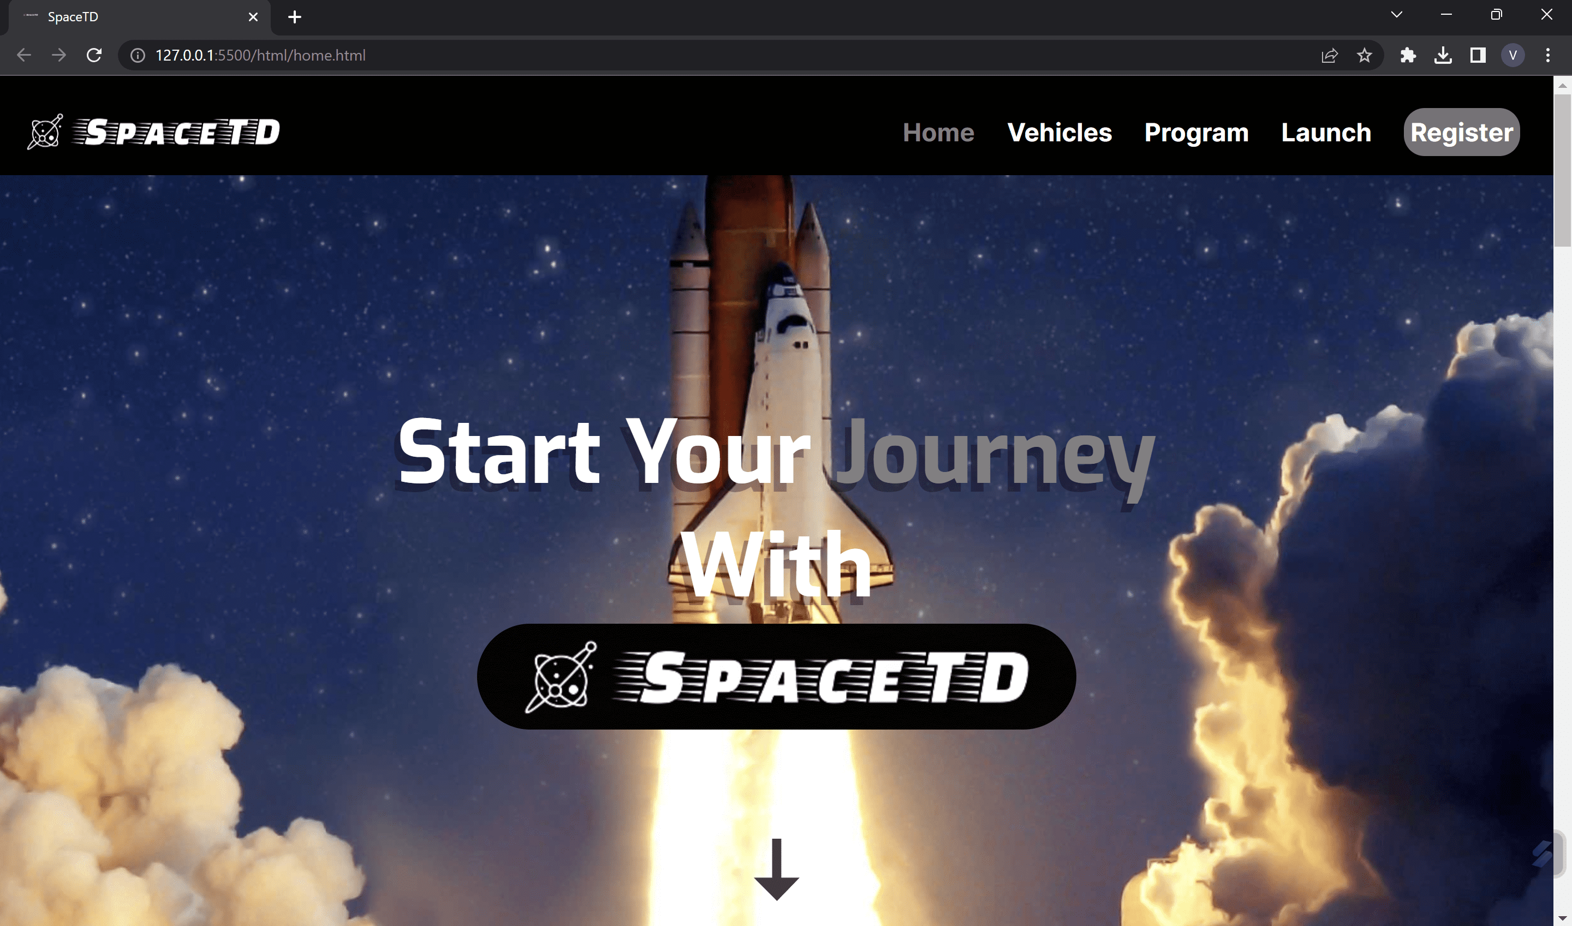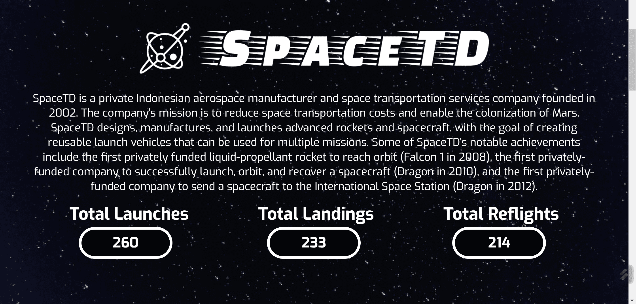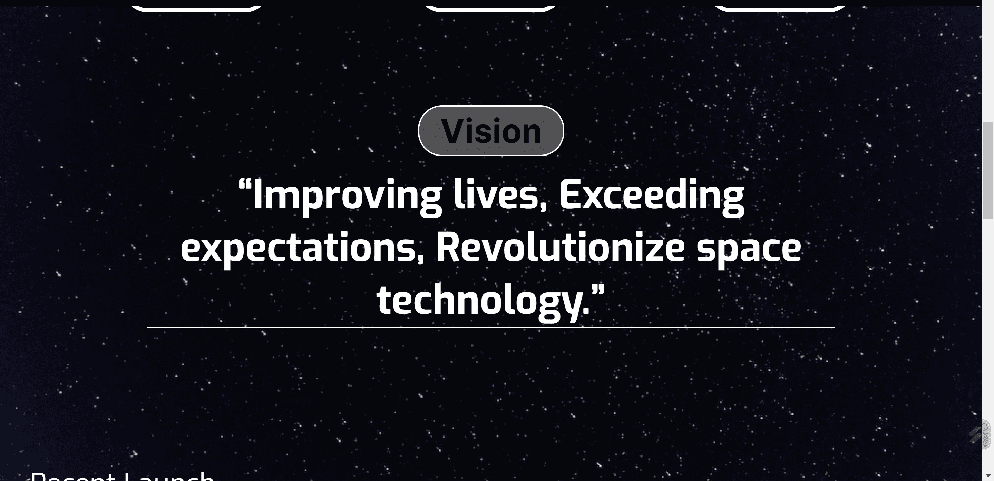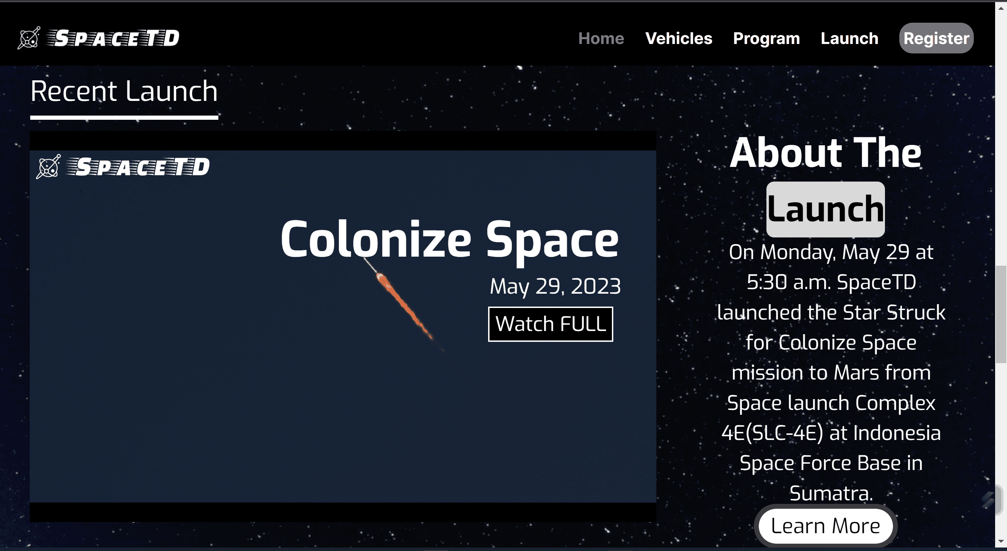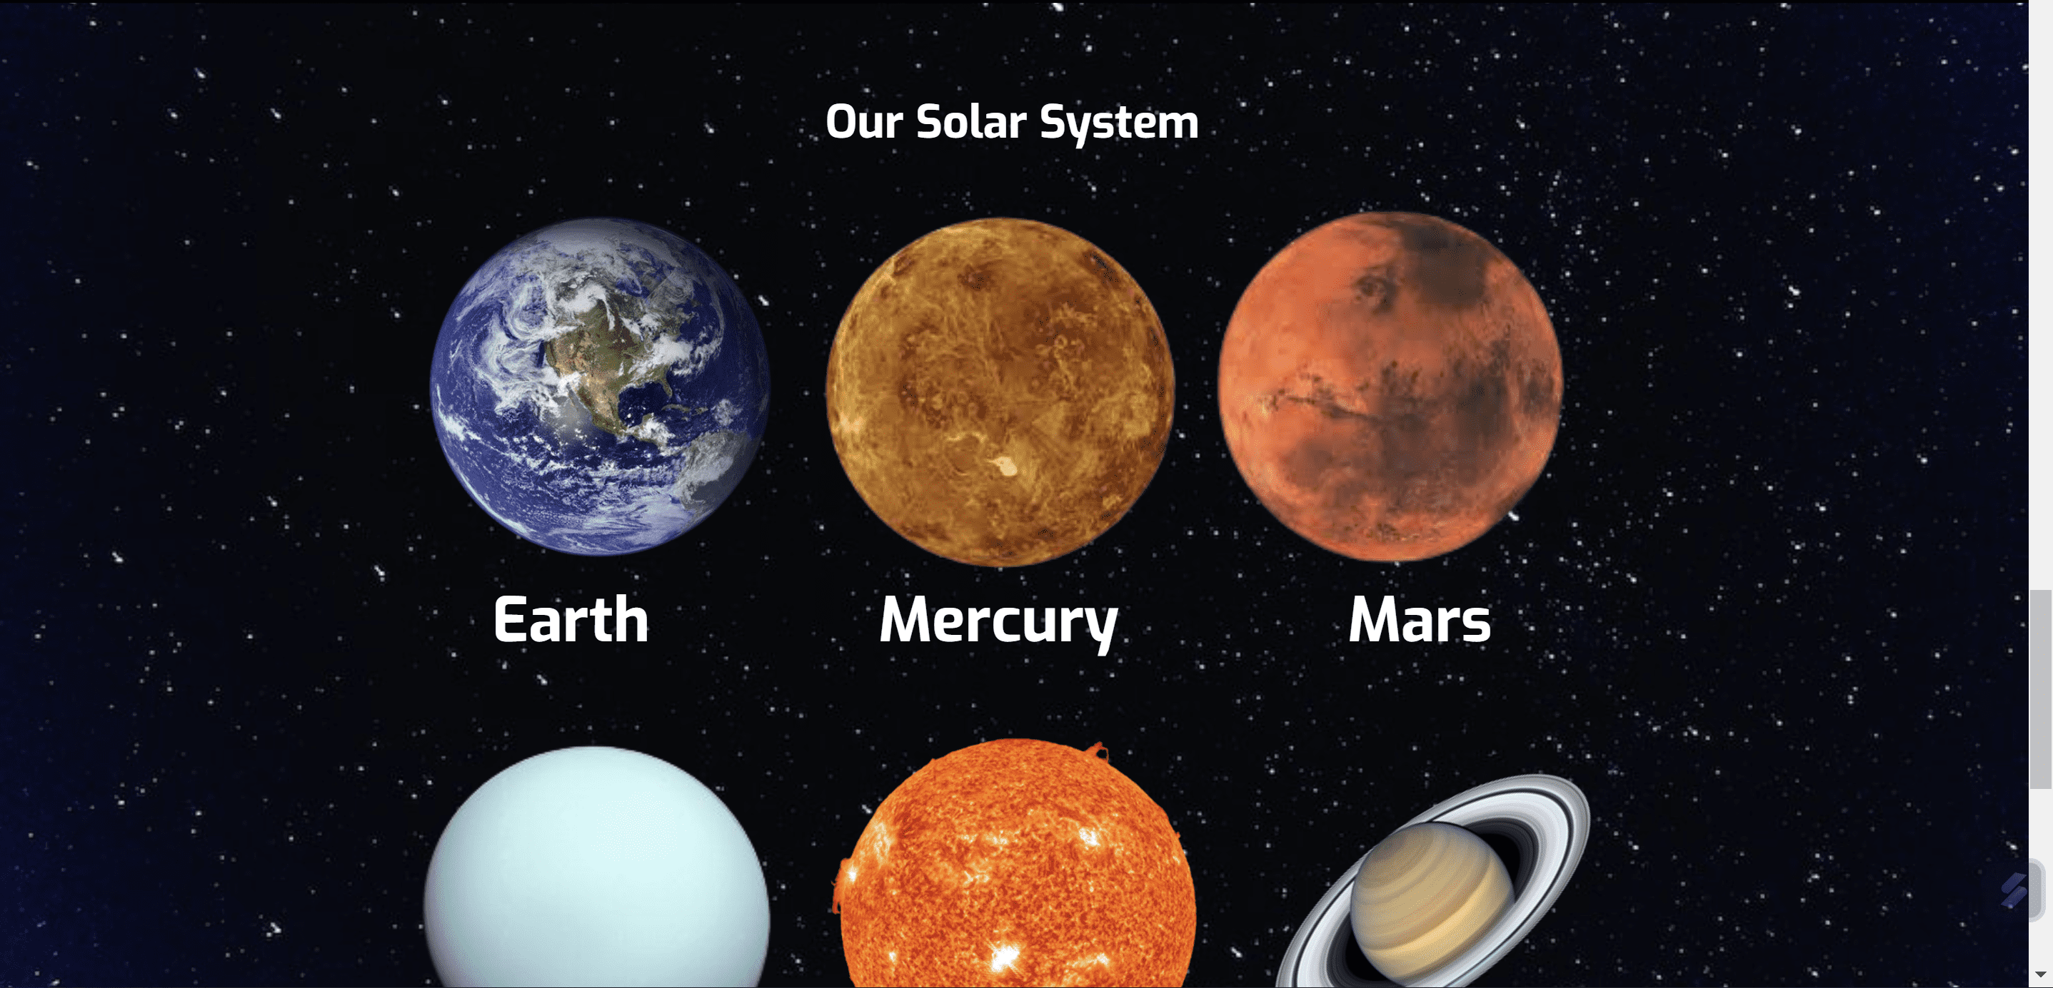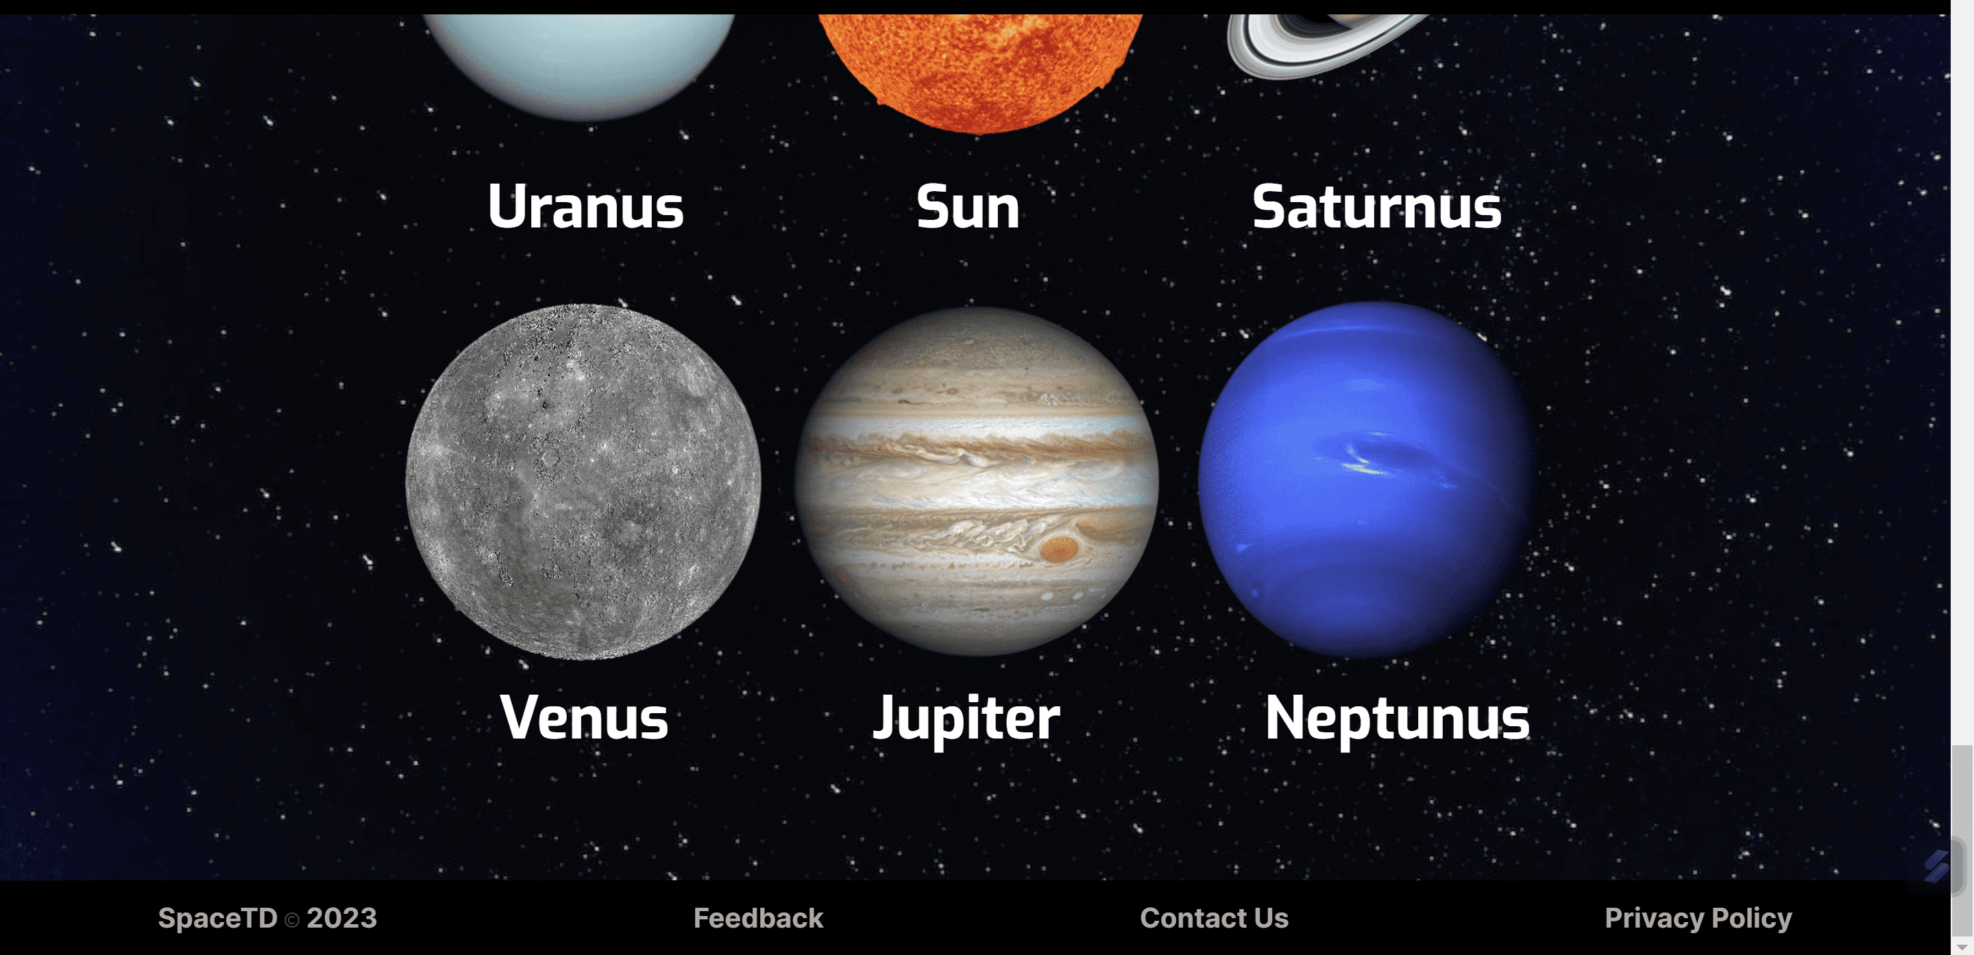

Design: The SpaceTD logo is made with a planet icon that symbolizes that SpaceTD is a company engaged in the world of astronomy. In the header part of the website, it uses a black fixed nav-bar that even if scrolled will remain in position. The contents of the nav-bar are spacetd logo, Home, Vehicles, Program, Launch, Register. The content of the body of the website uses a background of stars in space and the content starts from the welcome container which contains a welcome for users with a background image of a rocket launching. With writing and arrows pointing down indicating that there is other content below.

Continued with a profile view of the SpaceTD company which contains a company profile, total launches, total landings, and total reflights as well as the vision that the company has and wants to realize.

Then there is the recent launch content which contains the latest mission carried out by SpaceTD with a short video accompanied by the mission name, mission date, link to watch the full video, and an explanation of the mission carried out.

The last content on the home page is to display the planets in the solar system along with their names so that people can know the various planets around us.

And at the bottom, there is a footer that contains the ownership rights of the SpaceTd company, the feedback button, contact us and the company's privacy policy. The footer is in at every pages.

Interaction: the first interaction that can be done is to press the button on the nav-bar that can lead to the intended page by giving a gray color to the text when hovered. The second interaction that can be done is in the recent launch section, you can press the watchfull button which has a link to the youtube full video link from the launch, and there is a learn more button which when hovered can provide a more prominent color.

**Mobile View**

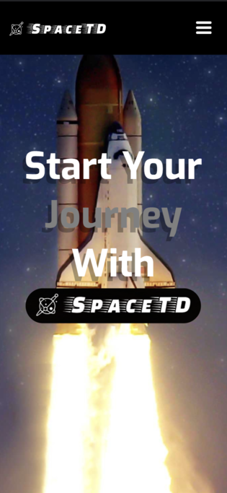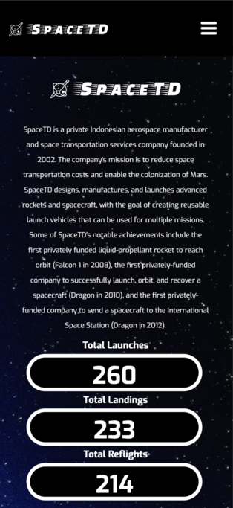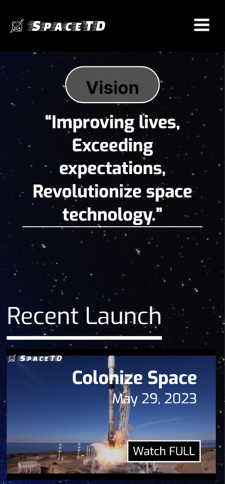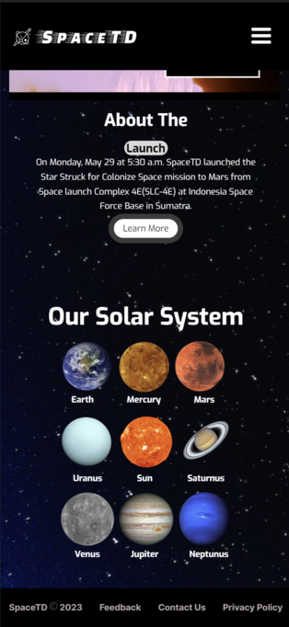

Design: the design of desktop view and mobile view is not much different, only the width and height of the content are adjusted to be compatible and responsive to mobile, changing some content positions to make it suitable. The size of the text also changes. On mobile view also the nav-bar changes to a hamburger button which if clicked will dropped down the nav-bar and can only appear if clicked and will disappear if the hamburger button is pressed again.

**2. Vehicles Page**

**Desktop View**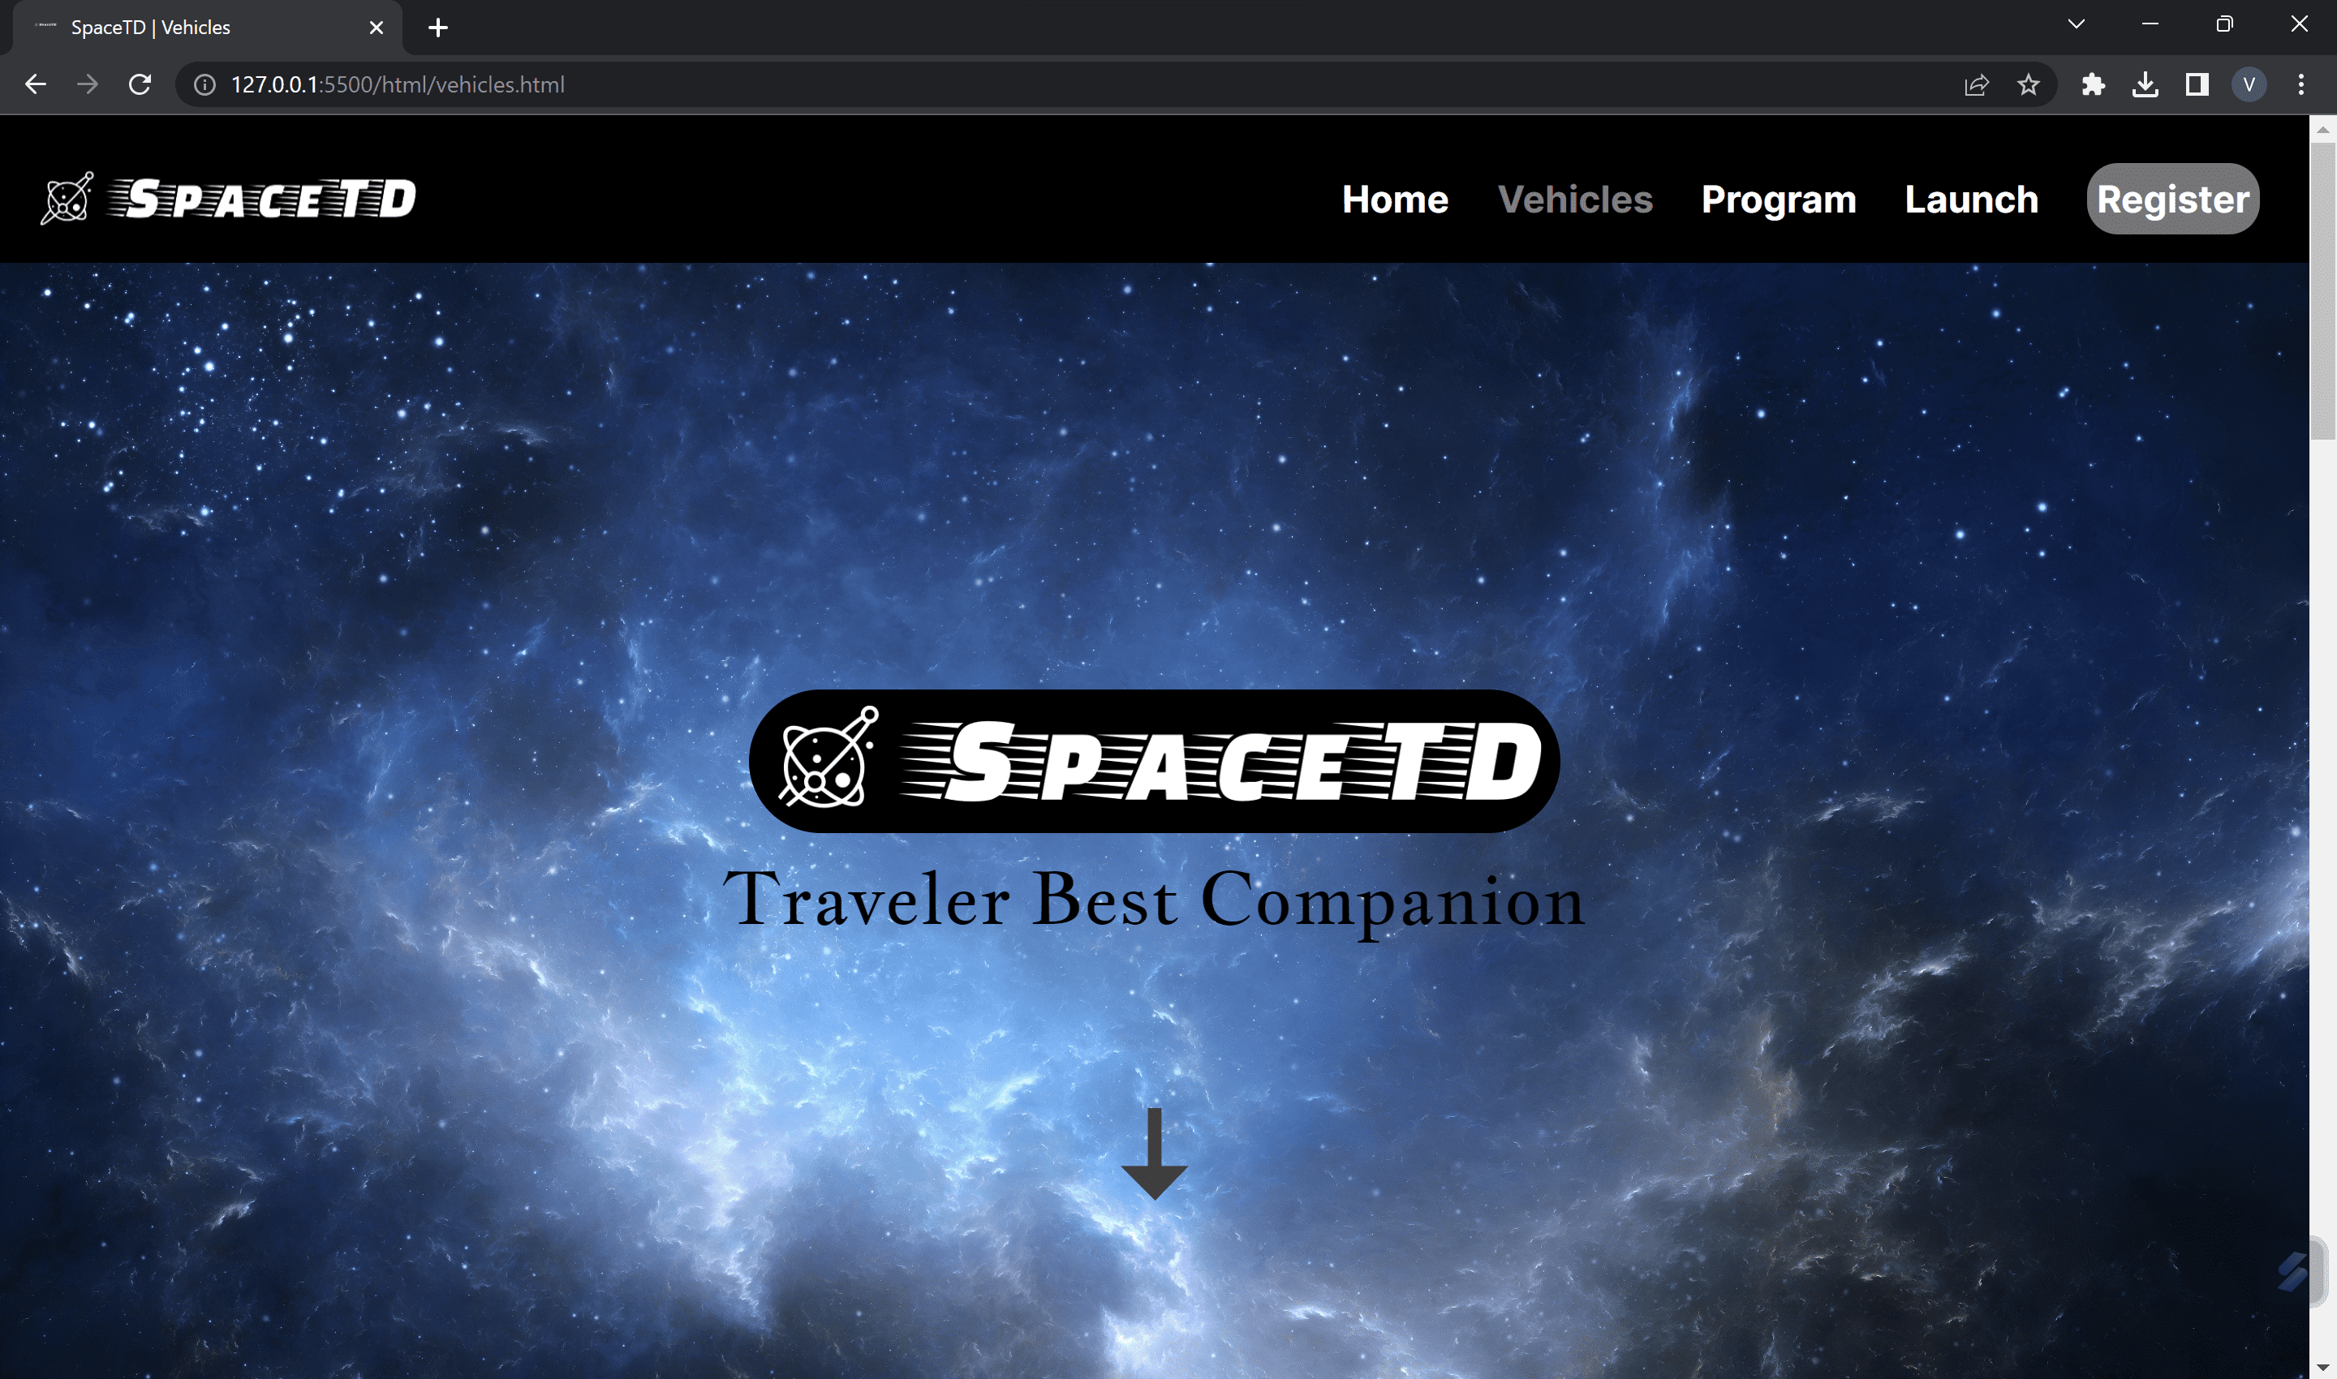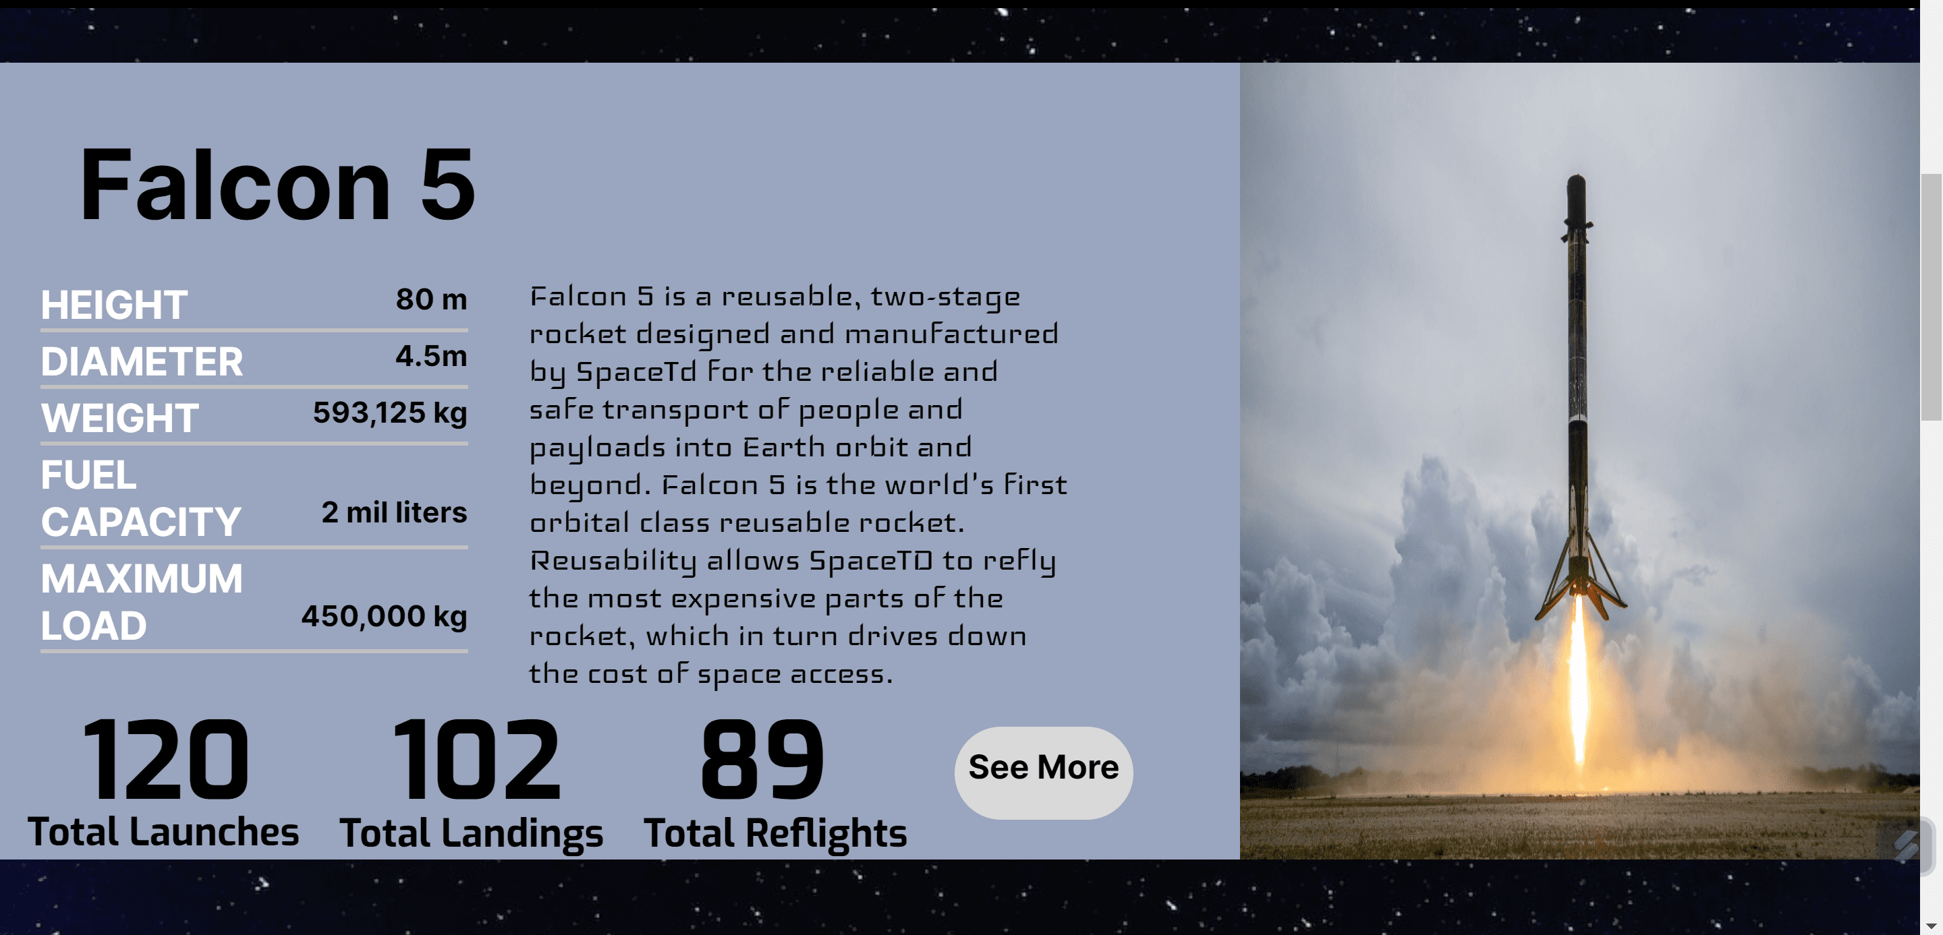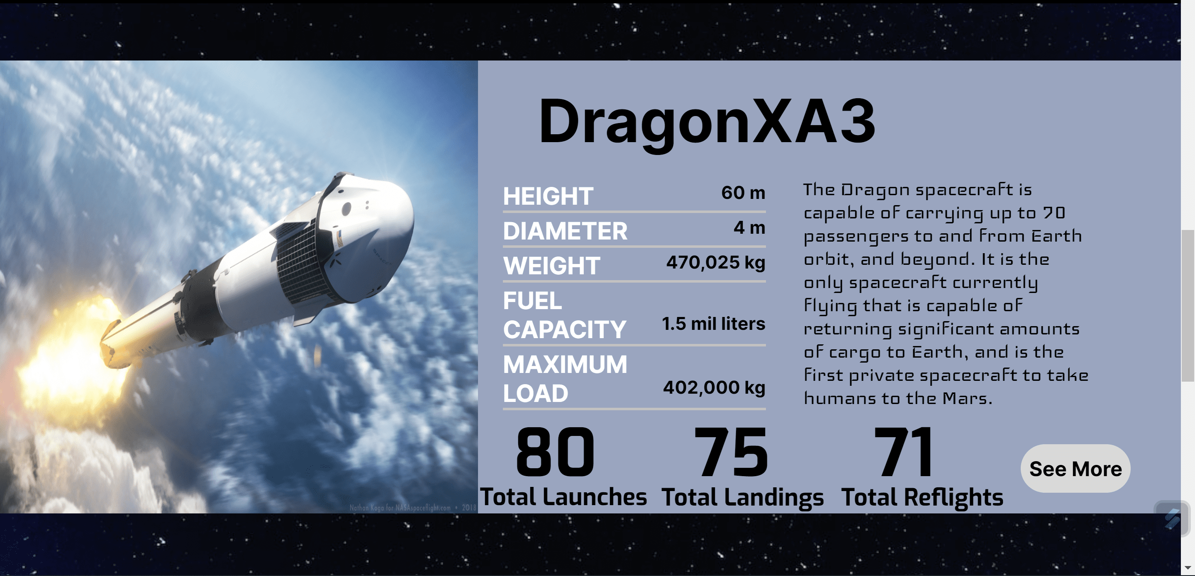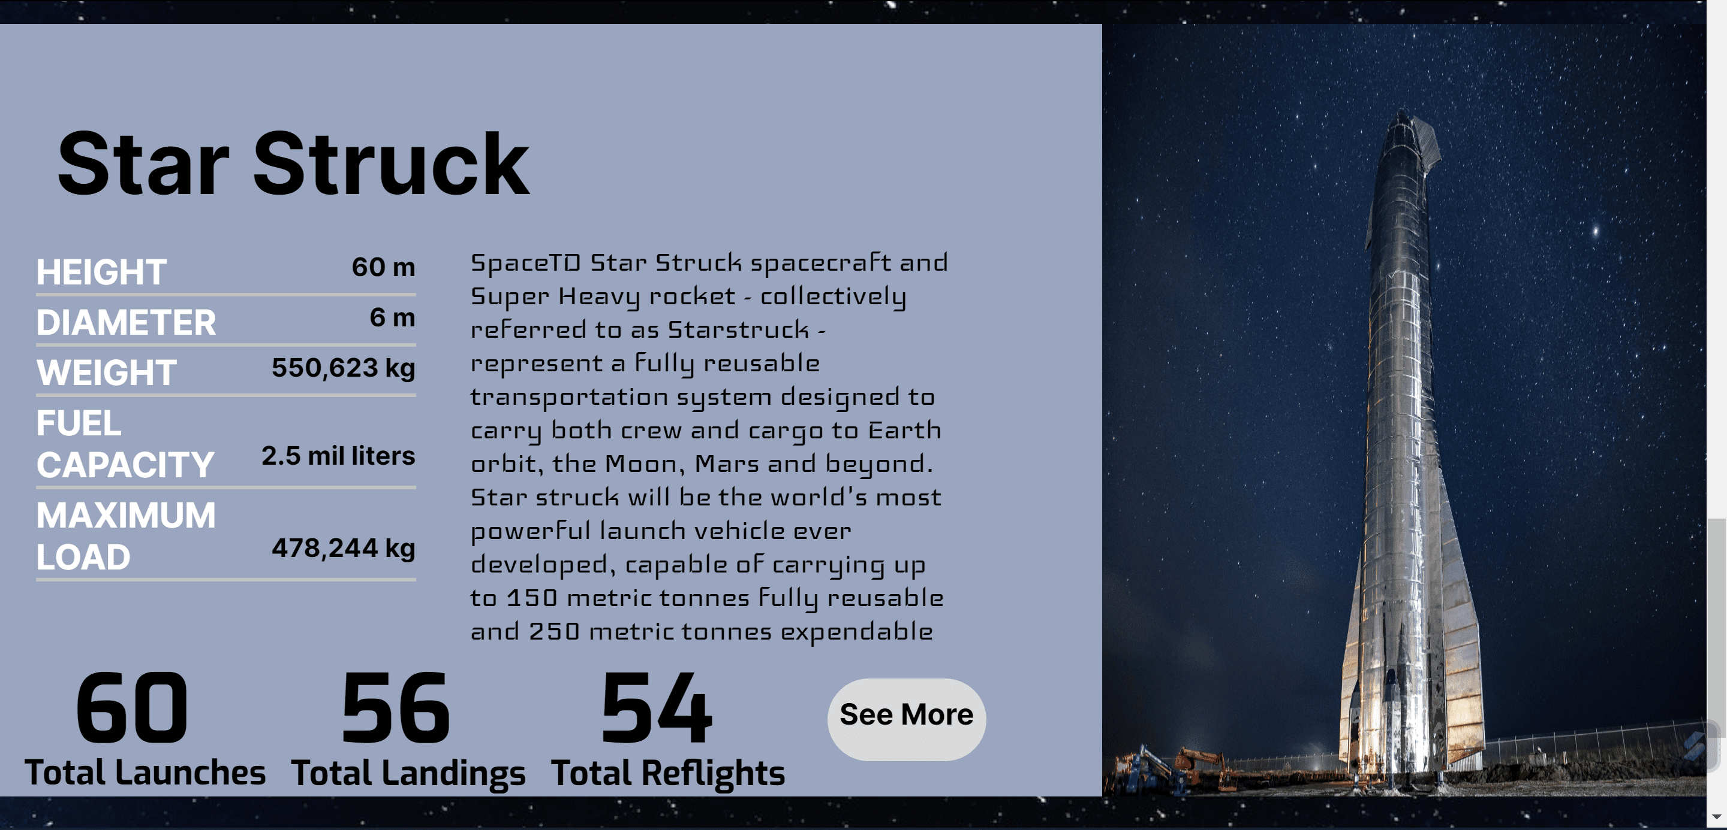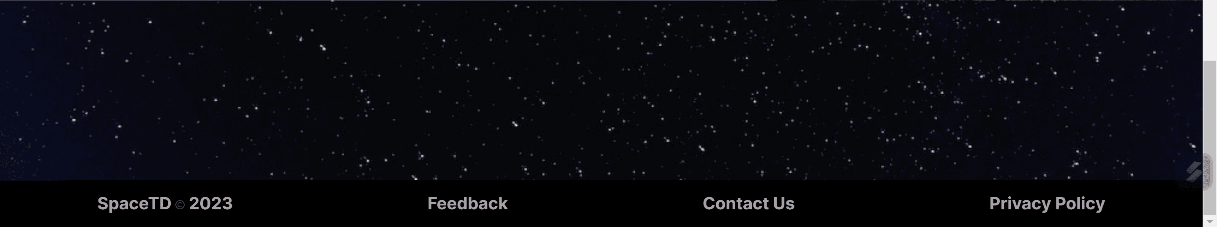

Design: the first display shows the slogan traveler best companion as a means of transportation that accompanies potential users. Then 3 types of rockets are displayed, each type displays a rocket image, rocket name, rocket overview, and total rocket launches as well as brief information about the rocket and there is also a button to view more information about the rocket.

Interaction: interaction that can be done in the form of a see more button that if hovered over will give a different color.

**Mobile View**

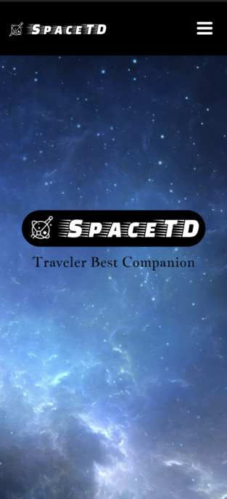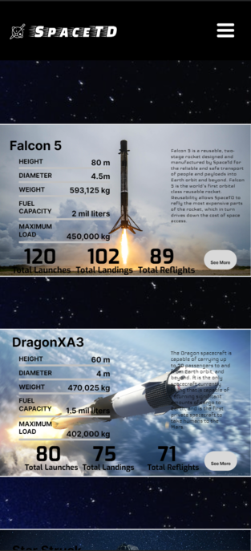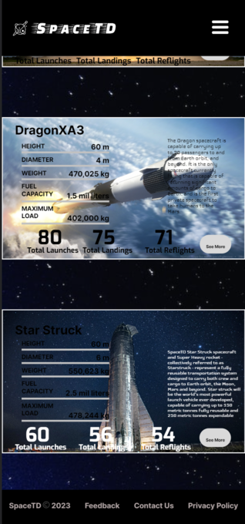

In mobile mode, the features offered are the same, except that there are changes in appearance that adjust to the mobile display. With the image changing to background-content, the size of the text changes to follow the mobile size as well.

**3.Program Page**

**Desktop View**

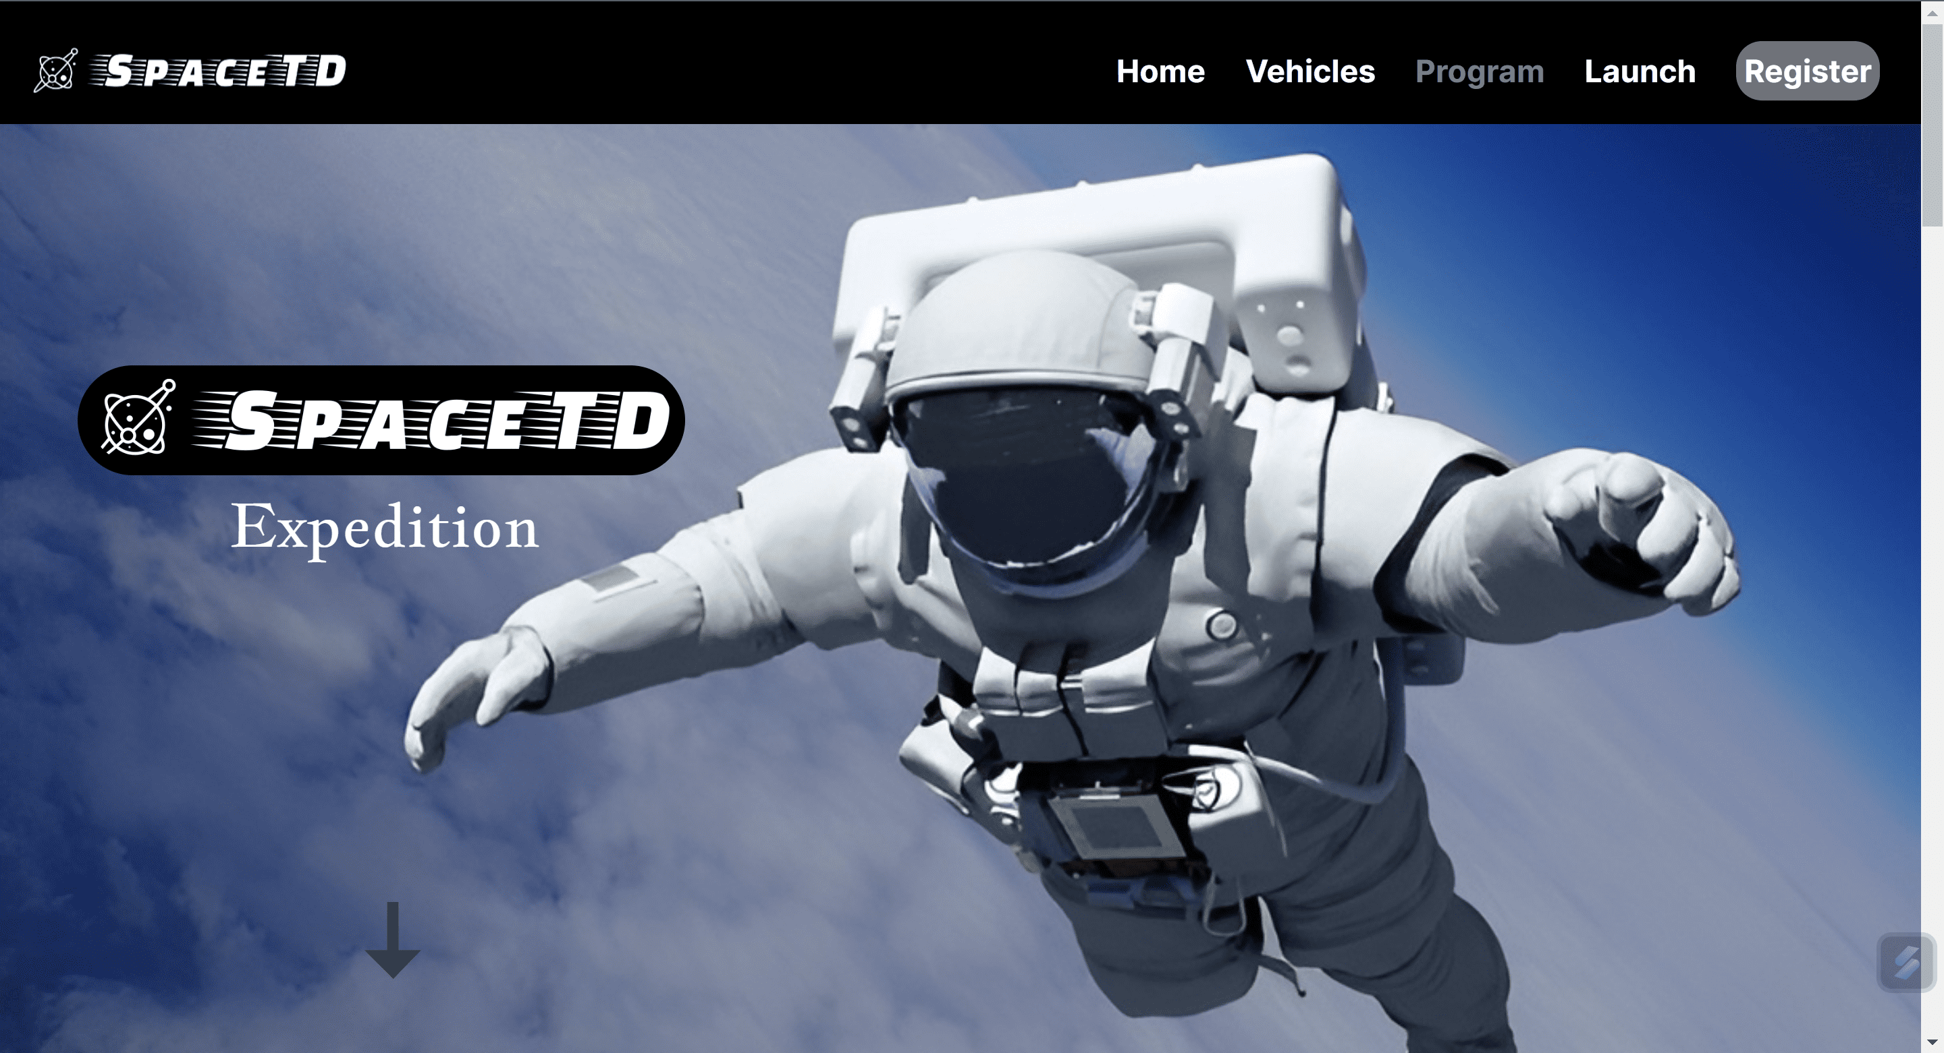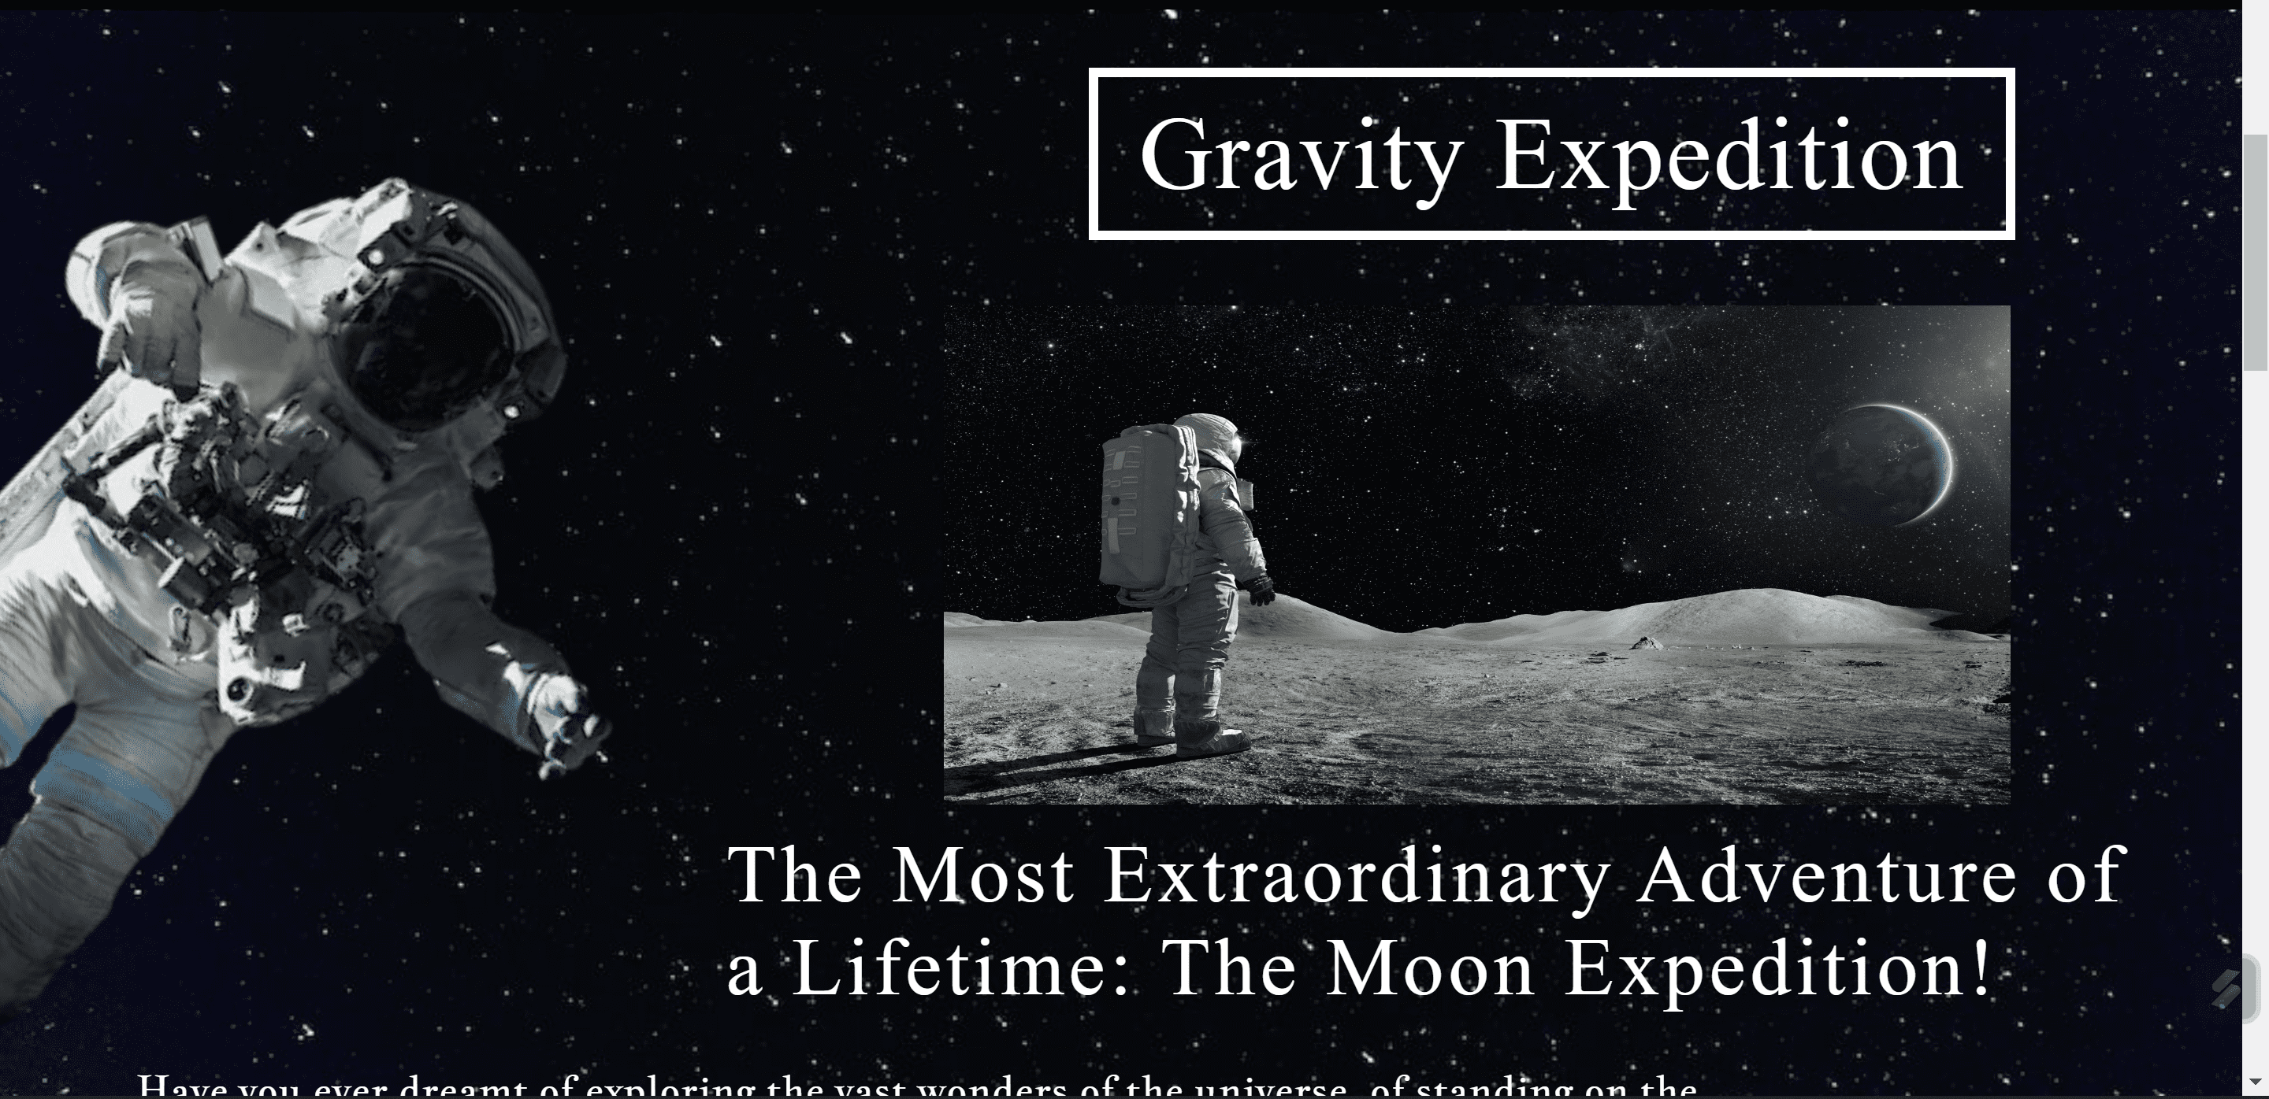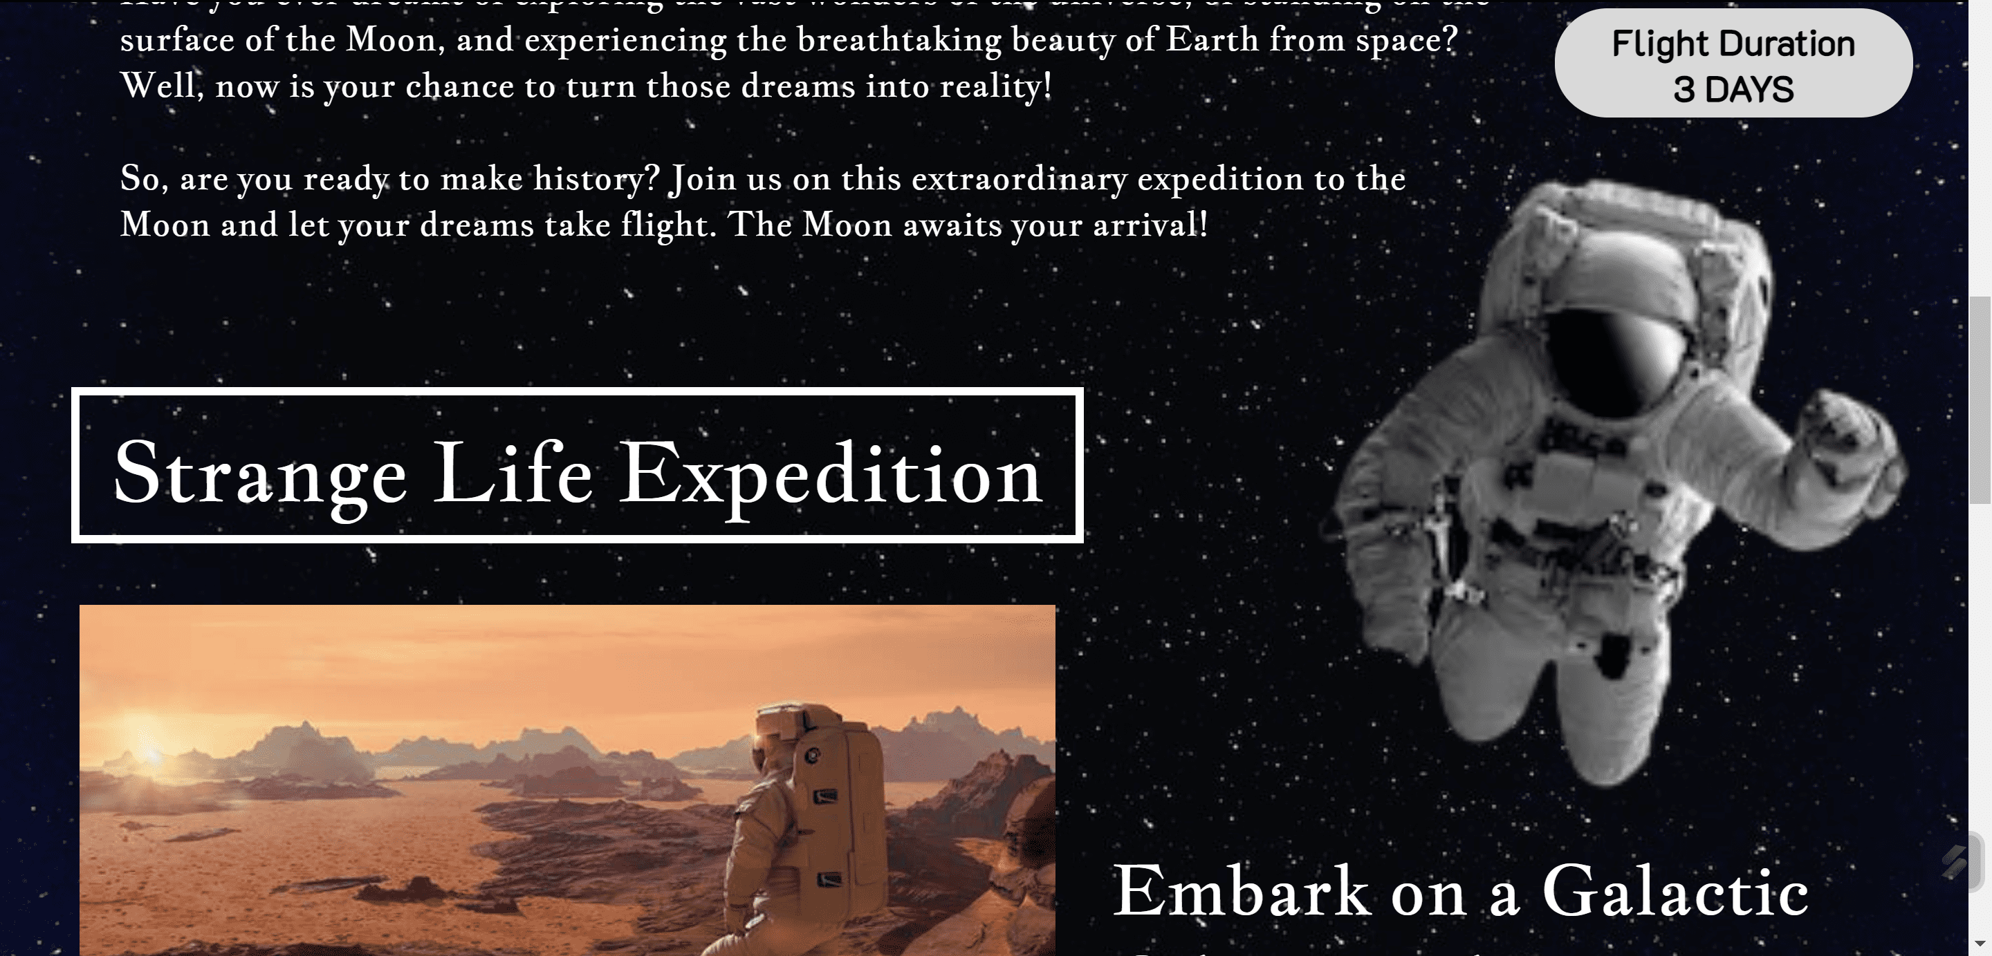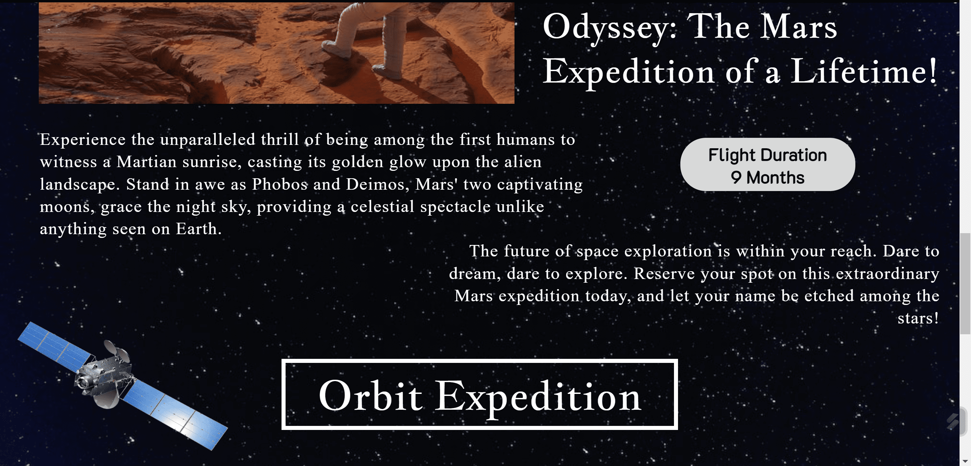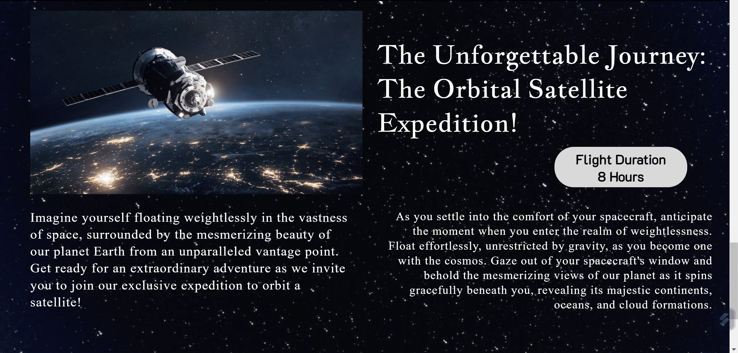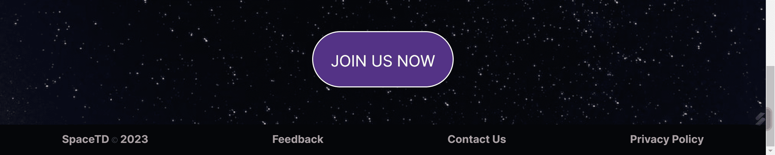

Design: On the initial display of the program page, also begins with content that contains a large image with the SpaceTD logo.

On this page there are 3 types of expeditions that can be carried out starting from the moon, to mars and to orbit, the display is also given an image of an astronaut floating in the background. Each type of expedition is given information about the expedition briefly, as well as the total time traveled to reach the destination, with also images about the expedition, in the body content section below there is a join us button to invite readers to join the expedition.

Interaction that can be done in the form of a button that says flight duration which if hovered will give a different color and if clicked will redirect us to the register page.

On the purple Join Us button there is also a special effect if it is hovered and if it is clicked it will redirect us to the register page.

**Mobile View**

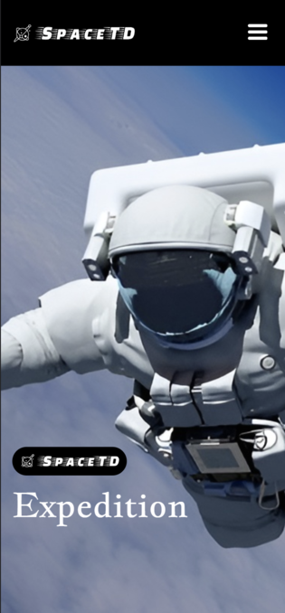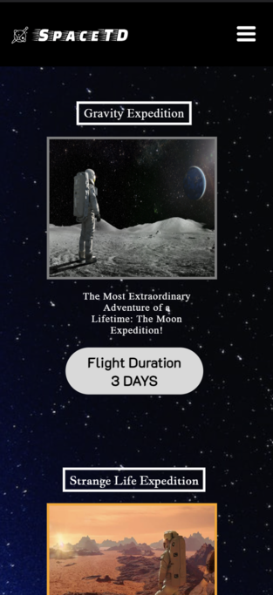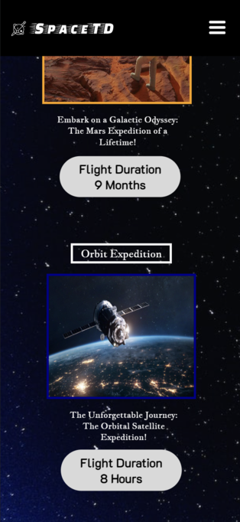

On mobile design, I made the display as simple as possible by eliminating brief explanations and displaying content in the middle to make it seem more elan and exclusive, for the join us button I removed it on the car because by clicking the flight duration button it can directly redirect to the register website. the interaction that can be done is the same as the interaction on the desktop.

**4. Launch Page**

**Desktop View**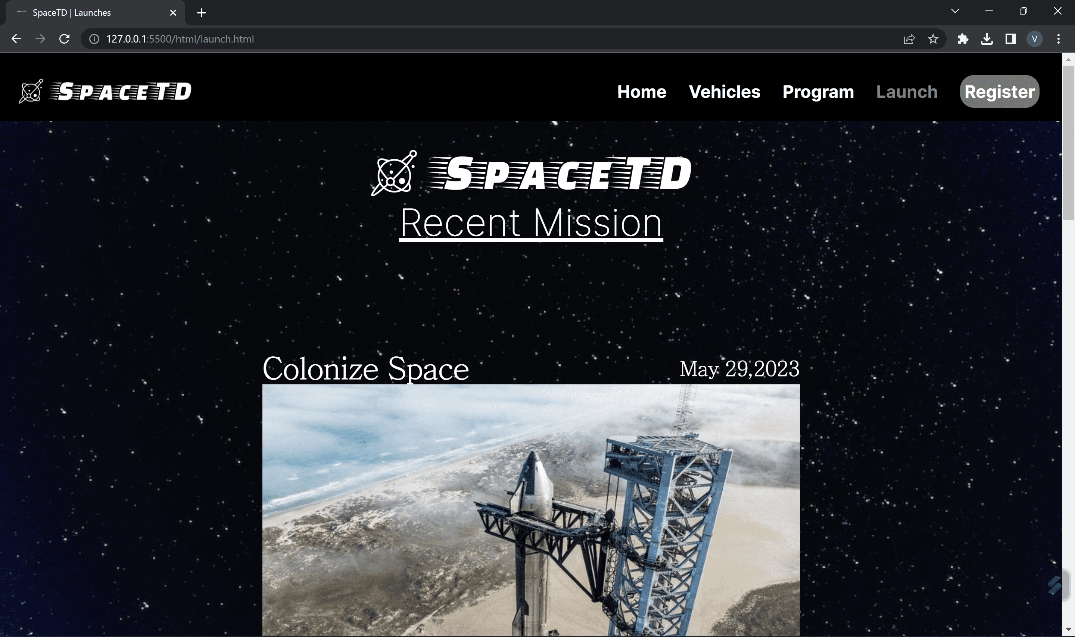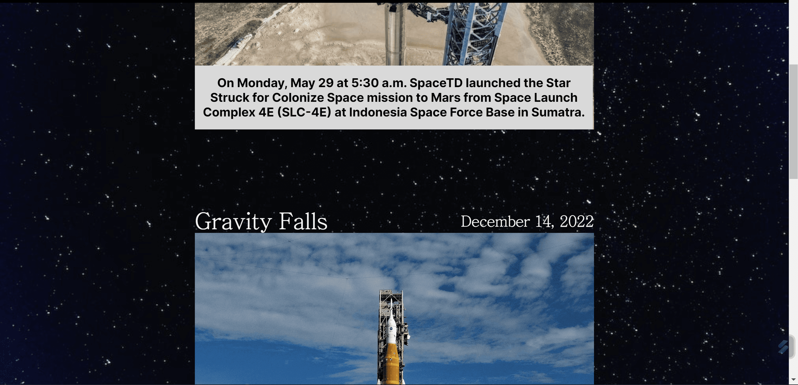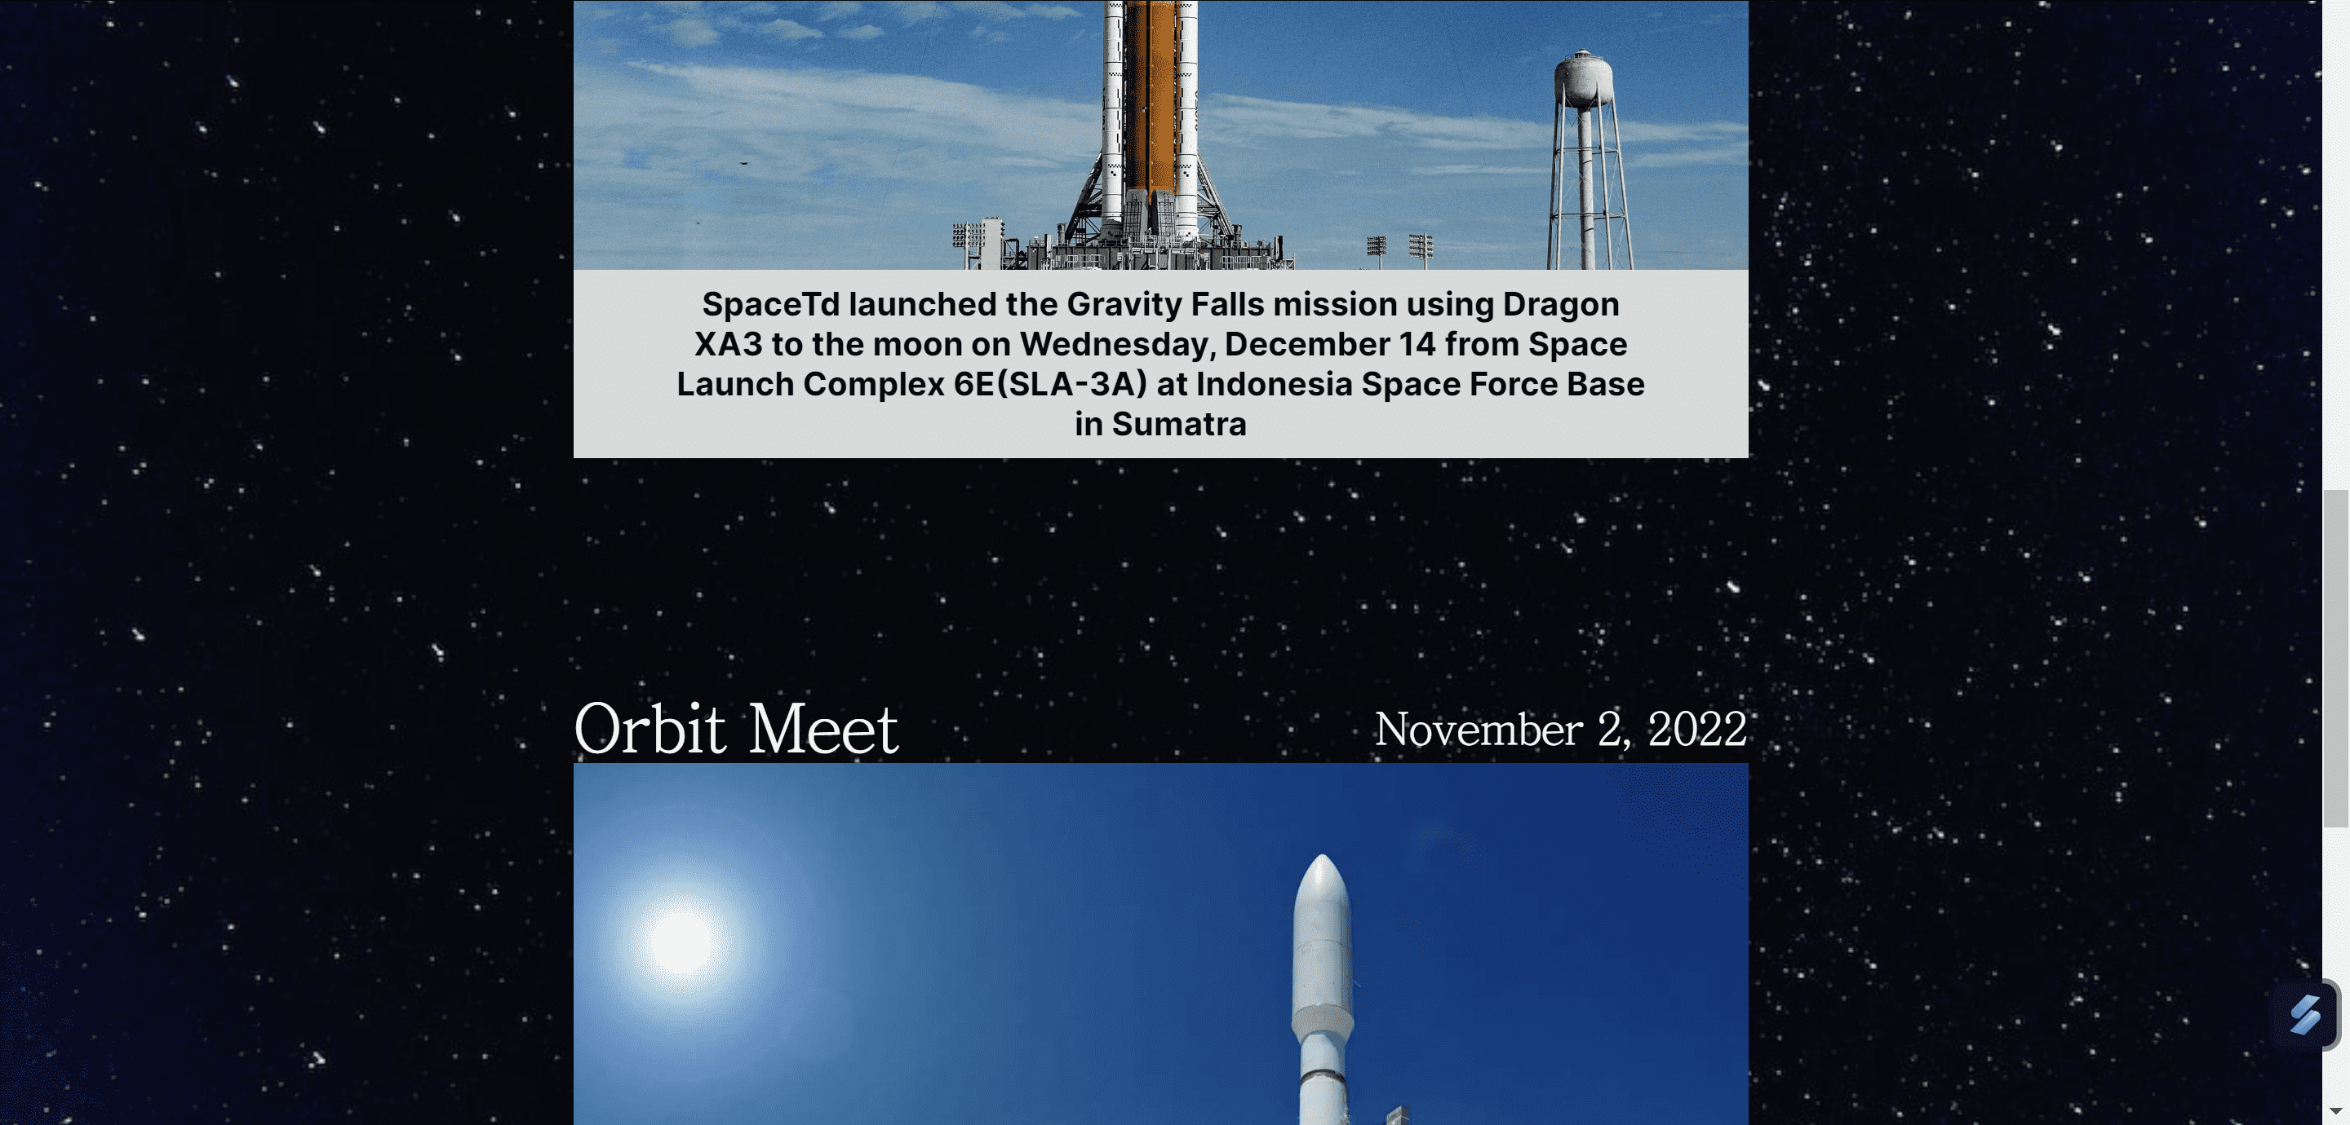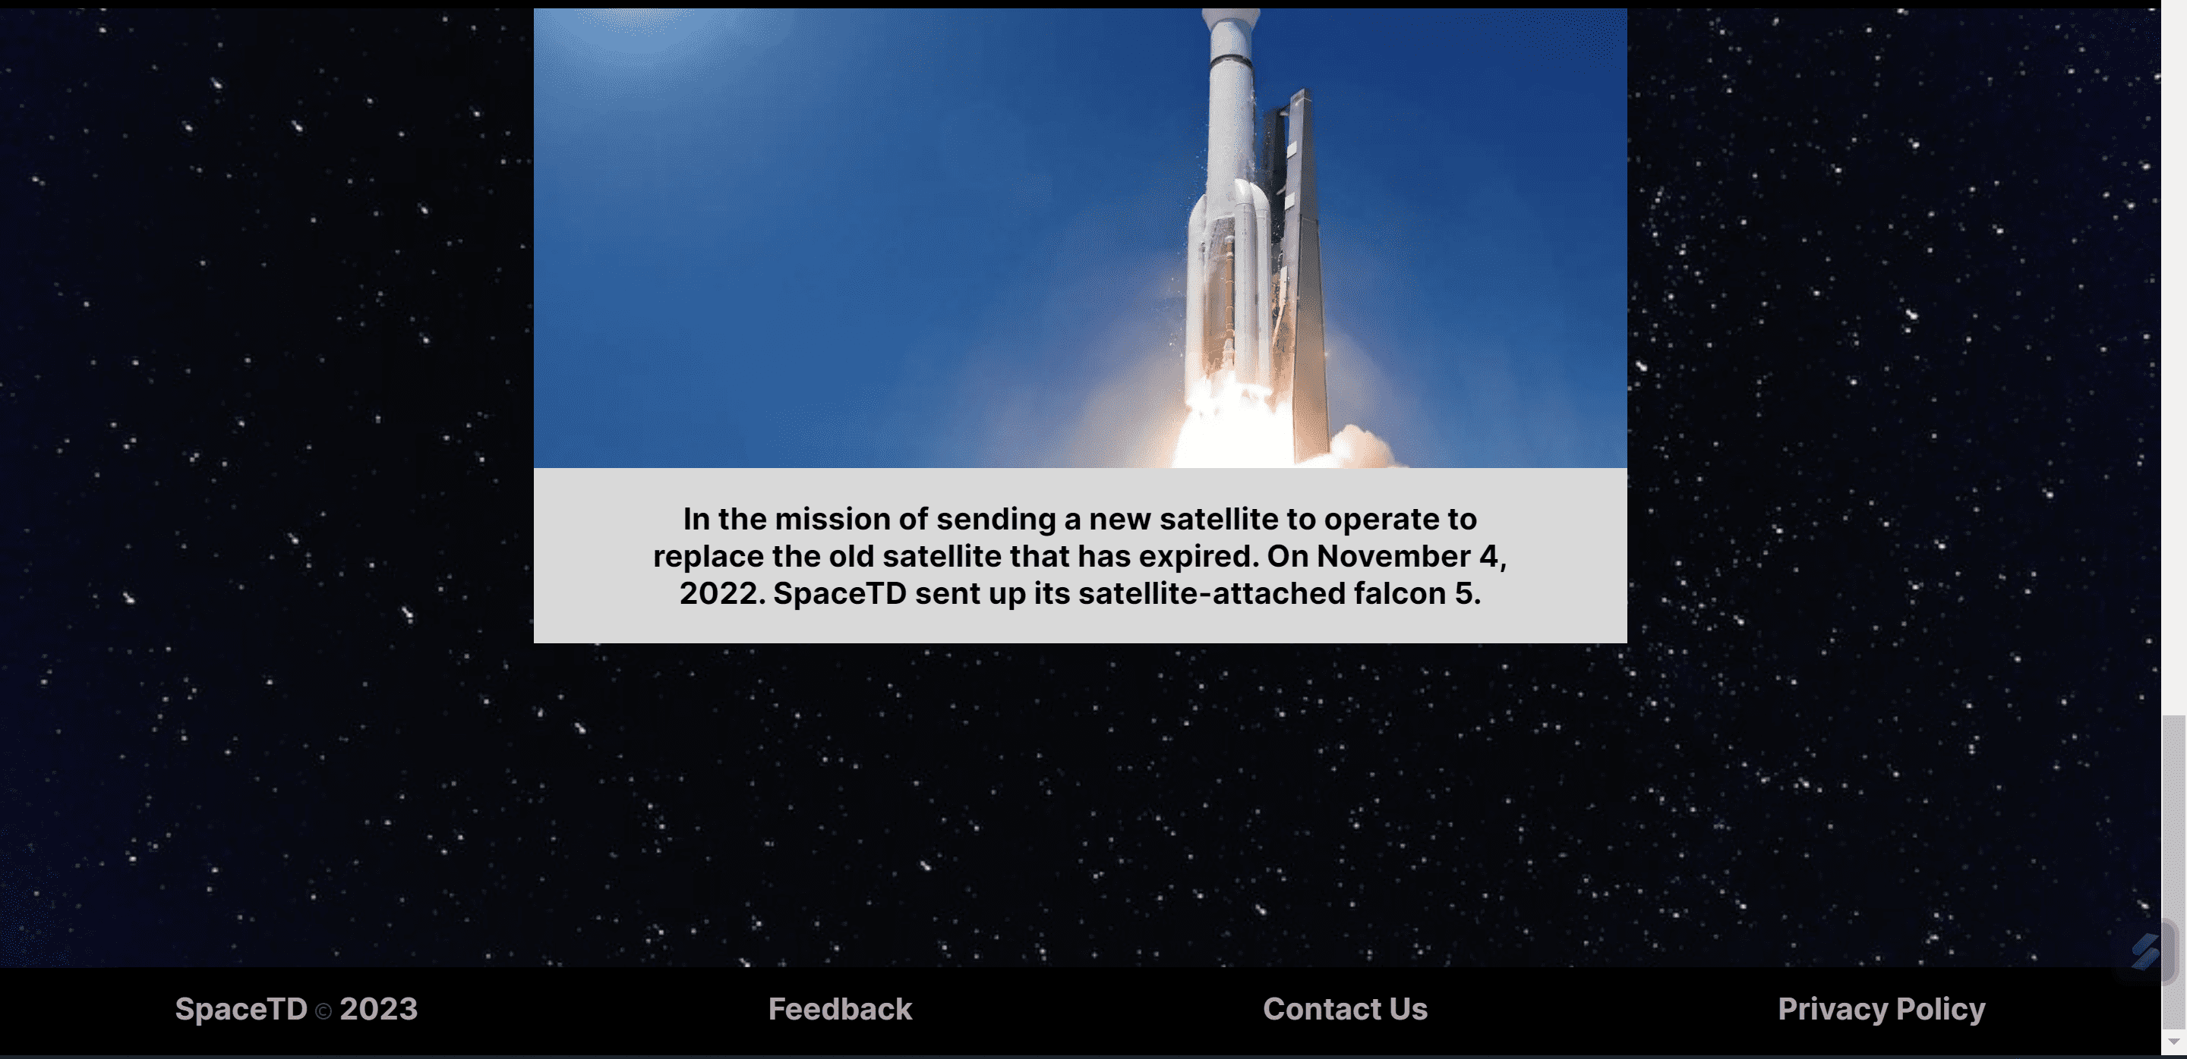

In the launch section, this is used to provide information about the latest missions that have been carried out, the information provided for each mission is in the form of a mission name, mission date, and a brief description of the mission listed above the background with a picture of the rocket used by the mission.

**Mobile View**

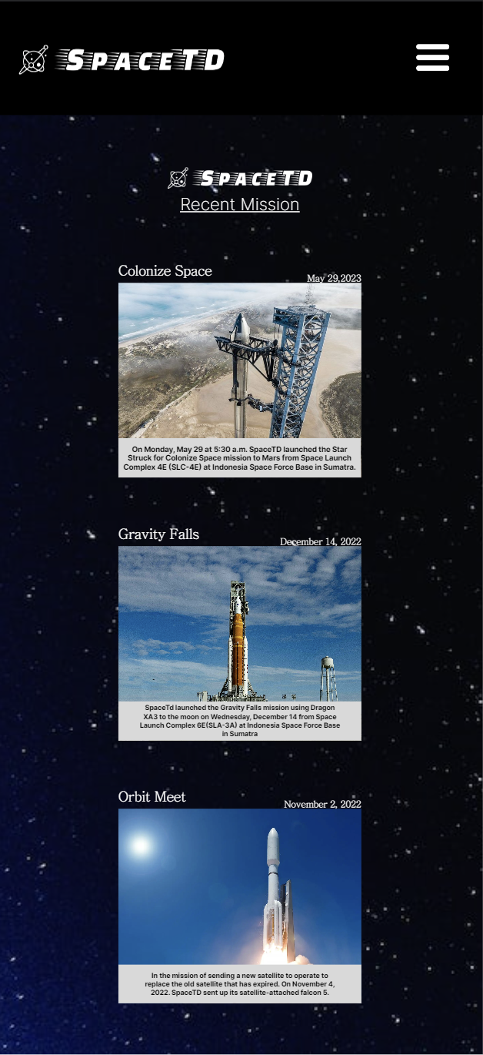

There is no difference in mobile view, there is only a difference in font size, there is still a hamburger button navbar and footer at the bottom of the page.

**5. Register Page  
Desktop View**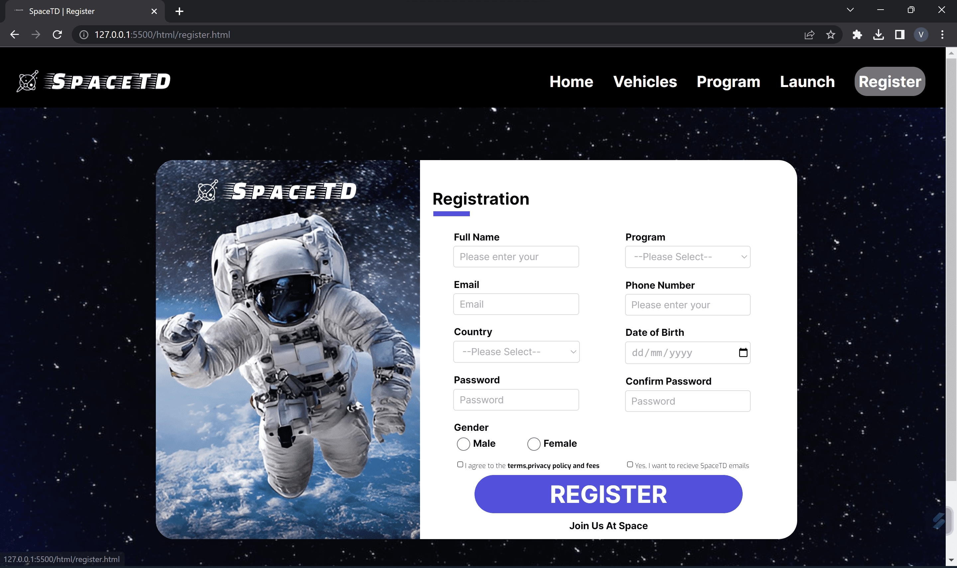

In the register section, there is a form that can be used to submit prospective user data, the form is divided into 2 parts, the left part has an image of an astronaut in space with the spacetd logo. On the right there is a user registration starting from the name, email, nationality, password, the program you want to take, telephone number, date of birth and password confirmation, there are also gender options, each of which has validation and characteristics and registration is required to tick the box regarding agreement terms and sending email in order to press the register button.

For name validation, a minimum of 3 characters is required, email uses @ and ., choose one country from the existing country options, enter a password with a minimum of 6 characters that can be numbers or letters, choose one gender, choose one program from 3 existing programs, enter a telephone number of at least 6 numbers, choose a date of birth, and validate the same password as the previous password that has been filled in, if the input is not filled in correctly, a warning box will be given from the top of the website and cannot submit / register.

The interaction that can be done is in the form of filling in data in the input contact, clicking a button and selecting something, the register button if hovered will give a black outline, and will redirect the filler to the Email Notification page.

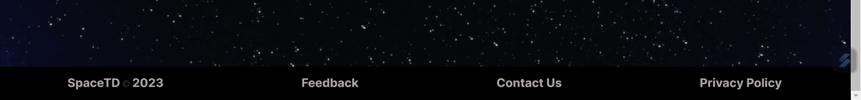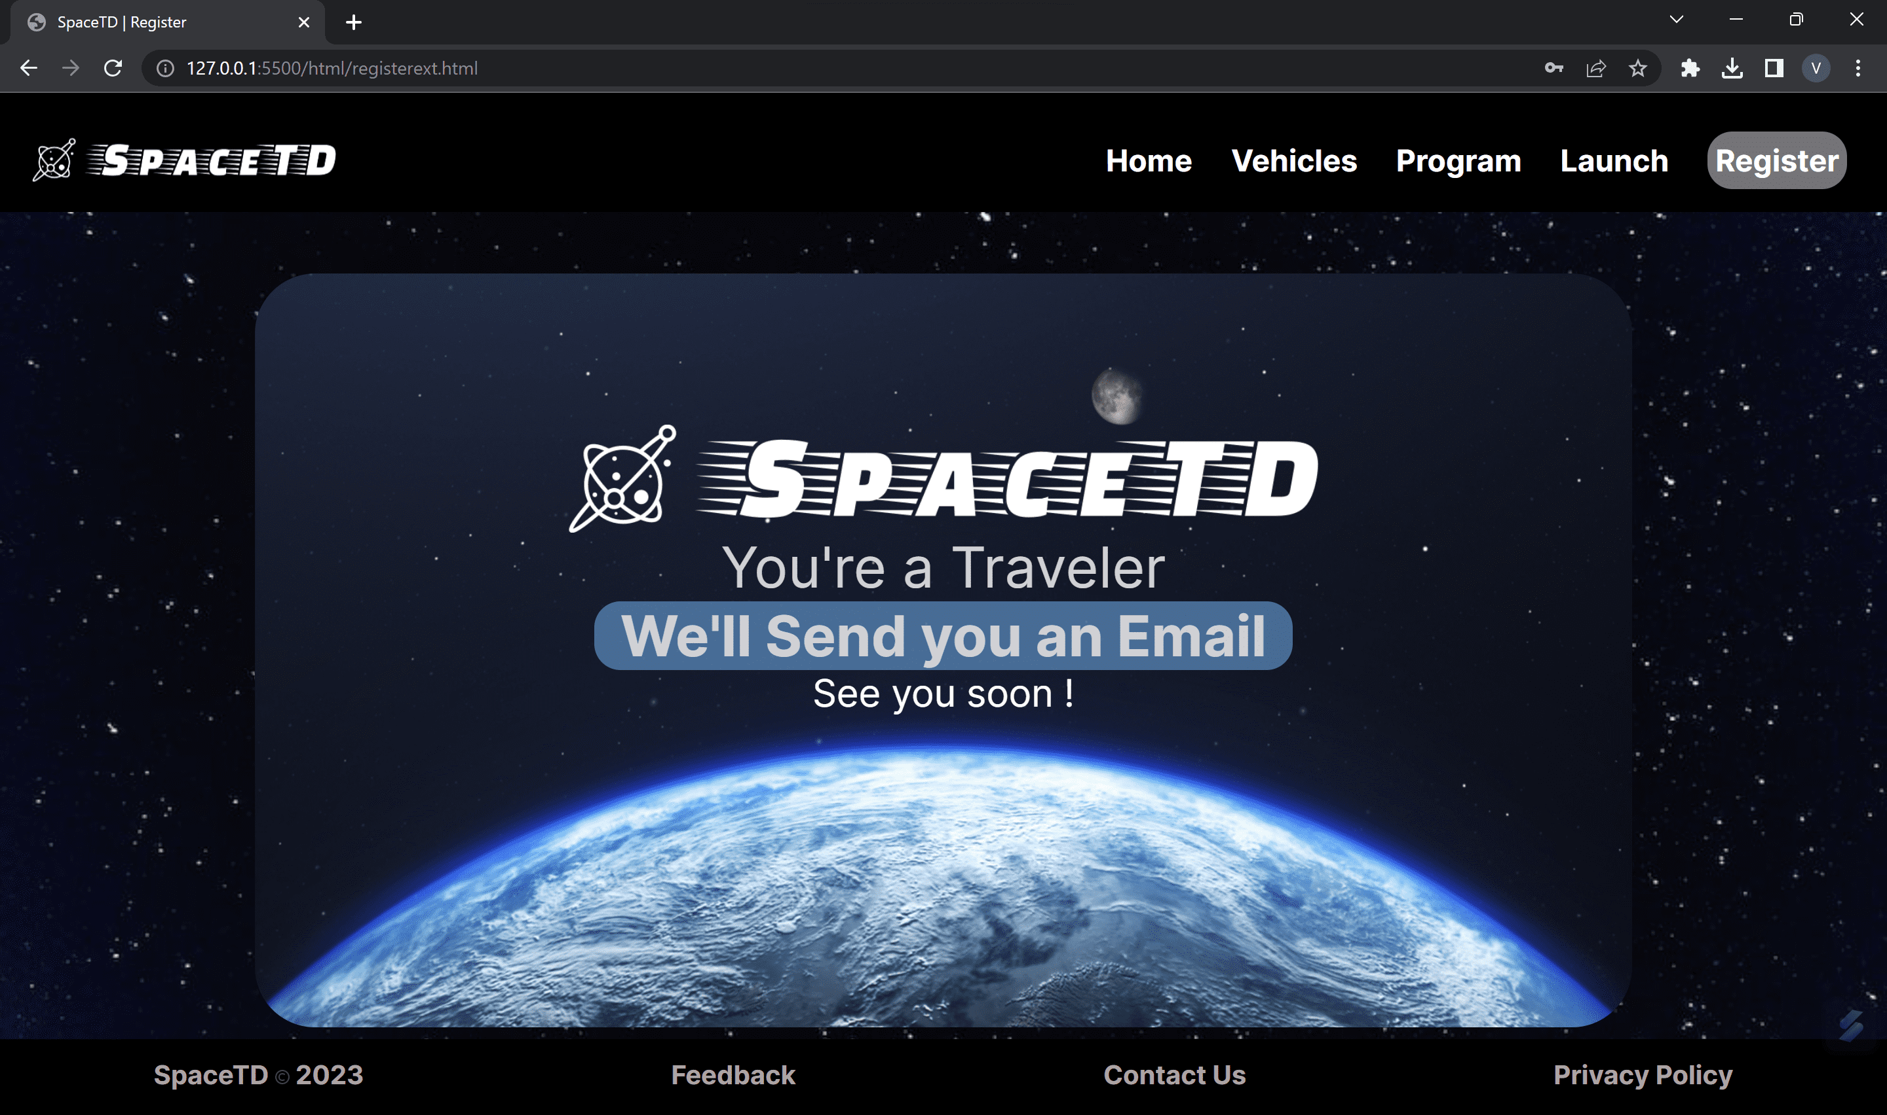

This email notification page is from the register page, after clicking the register button it will be redirected to this page, to be notified about the email entered a confirmation will be sent that the user has joined as an expeditioner

**Mobile View**

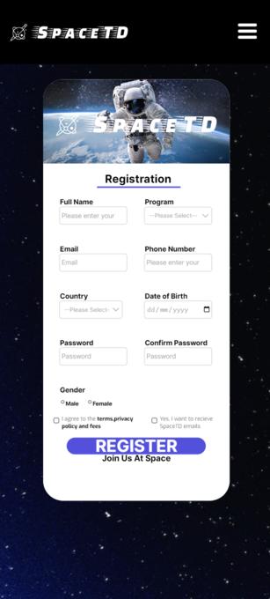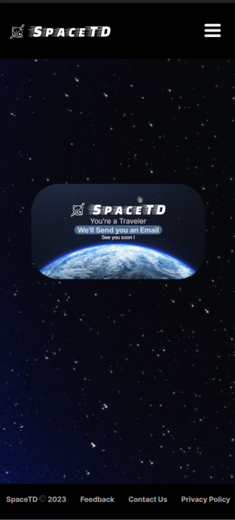

On the mobile view, only the position changes, on the mobile the left side of the transfer form is up and the right part of the form is down so that it becomes a column, the features and buttons provided are all the same, only the font size is different. There is still a hamburger button on the navbar and footer at the bottom.

Link asset:  
1. Font

* Font-family: ‘Inter’

https://fonts.google.com/specimen/Inter

* Font-family: ‘Exo’

https://fonts.google.com/specimen/Exo

* Font-family: ‘Iceland’

https://fonts.google.com/specimen/Iceland

* Font-family: ‘JacquesFrancois’

https://fonts.google.com/specimen/Jacques+Francois

* Font-family: ‘JejuMyeongjo’

https://www.wfonts.com/font/jejumyeongjo

* Font-family: ‘K2D’

<https://fonts.google.com/specimen/K2D>

2. Images

* arrow.svg

https://www.figma.com/file/ue2mcDxPlTiMhWWnIcJPUx/SpaceTd?type=design&node-id=1-3&t=HHKuEitZBCwReG6I-0

* astronot terbang.png

https://img.freepik.com/premium-photo/astronaut-spaceman-spacewalk-while-working-space-station_31965-12609.jpg

* astronot_2_terbangs.png

https://storage.cloudconvert.com/tasks/fb986f31-a330-4c04-884e-5694d466d965/spaceman-open-space-background-stars-astronaut-travels-space-against-background-stars-elements-this-image-furnished-by-nasa_150455-13359.jpg?AWSAccessKeyId=cloudconvert-production&Expires=1685521052&Signature=3szpxcbIhAMGgMPJbbHdQhv9CjQ%3D&response-content-disposition=attachment%3B%20filename%3D%22spaceman-open-space-background-stars-astronaut-travels-space-against-background-stars-elements-this-image-furnished-by-nasa_150455-13359.jpg%22&response-content-type=image%2Fjpeg

* black.jpg

https://upload.wikimedia.org/wikipedia/commons/thumb/4/49/A_black_image.jpg/640px-A_black_image.jpg

* copyright.png

https://cdn-icons-png.flaticon.com/512/106/106852.png

* DragonXA3.jpg

https://www.nasaspaceflight.com/wp-content/uploads/2019/02/201922-171546.jpg

* earth.png

https://climatemirror.org/

* Falcon 5.jpg

https://cdn.mos.cms.futurecdn.net/P6Qy9QgewcweJpsXjG2tzL.jpg

* fotoorbit.jpg

https://cdn.mos.cms.futurecdn.net/ivDMoYPyqyUHYyiKjkAeK3-1200-80.jpg

* jupiter.png

https://www.seekpng.com/ipng/u2t4r5u2w7e6t4t4_jupiter-planet-clipart/

* kebulan.jpg

https://cdn.mos.cms.futurecdn.net/ZsAT7365H9z2re2tF4CJwa.jpg

* mars.png

https://proofmart.com/product/mars-png-images-transparent-background-free-download/

* marslife.jpg

https://telset.id/wp-content/uploads/2022/05/mARS-astronaut.jpg

* menu icon.png

https://www.pinterest.com/pin/723109283914968181/

* mercury.png

https://www.publicdomainpictures.net/en/view-image.php?image=86468&picture=planet-venus

* mission1.jpg

https://pict.sindonews.net/dyn/850/pena/news/2023/02/06/767/1016003/spacex-pastikan-roket-starship-meluncur-maret-mendatang-oyu.jpg

* mission2.jpg

https://static01.nyt.com/images/2022/11/15/science/15nasamoon-preview1/15nasamoon-preview1-videoSixteenByNine3000.jpg

* mission3.webp

<https://www.skyrora.com/wp-content/uploads/2022/05/orbital-launch-vehicle.jpg>

* neptunus.png

https://www.clipartkey.com/view/iJTwhm_vector-system-solar-transparent-png-clipart-free-download/

* registerastronot.jpg

https://ar.europeanwriterstour.com/images-2023/are-there-still-astronauts

* registerext.jpg

https://nhpbs.org/space/

* satelitorbit.webp

https://www.psn.co.id/wp-content/uploads/2017/05/Satelit-PSN-VI_clear-e1643179295492.png

* saturnus.png

http://t2.gstatic.com/images?q=tbn:ANd9GcR9iGMNL9bSEOXhSwWU1a7TtwosV2OaoWdfW9iY03DqWkVPpy70

* spacetdLogo.png

https://app.logo.com/dashboard/logo_ad7794a8-e6af-48a1-8da3-73e54a684ddc/your-logo-files

* star struck.webp

https://hips.hearstapps.com/hmg-prod/images/starship-1586187865.jpg?crop=0.61953125xw:1xh;center,top&resize=1200:

* sun.png

https://science4fun.info/sun/

* uranus.png

https://backyardstargazers.com/observing-the-planets/

* vehicleswelcome.jpg

https://wallpapercave.com/wp/wp2562160.jpg

* venus.png

https://bigkidscience.com/planetary-tour/mercury/

* web-background.jpg

https://www.yourvalley.net/stories/luke-says-mondays-sonic-boom-over-west-valley-not-from-base-jets,375066

* Welcome Rocket.png

http://www.mcsimg.com/

* WelcomeProgram.jpg

<https://awsimages.detik.net.id/community/media/visual/2016/10/28/d02fcb73-c483-476f-b910-3374e6c423e9.jpg?w=600&q=90>

**VIDEO**

* falcon 9 video.mp4

https://www.youtube.com/watch?v=Z4TXCZG_NEY

**Website References**

* <https://www.spacex.com/>
* <https://solarsystem.nasa.gov/>
* https://viewspace.org/